Great Start to Quality

School-Age Program Quality Assessment (PQA)

On-Site Assessment Support Document
June 2020

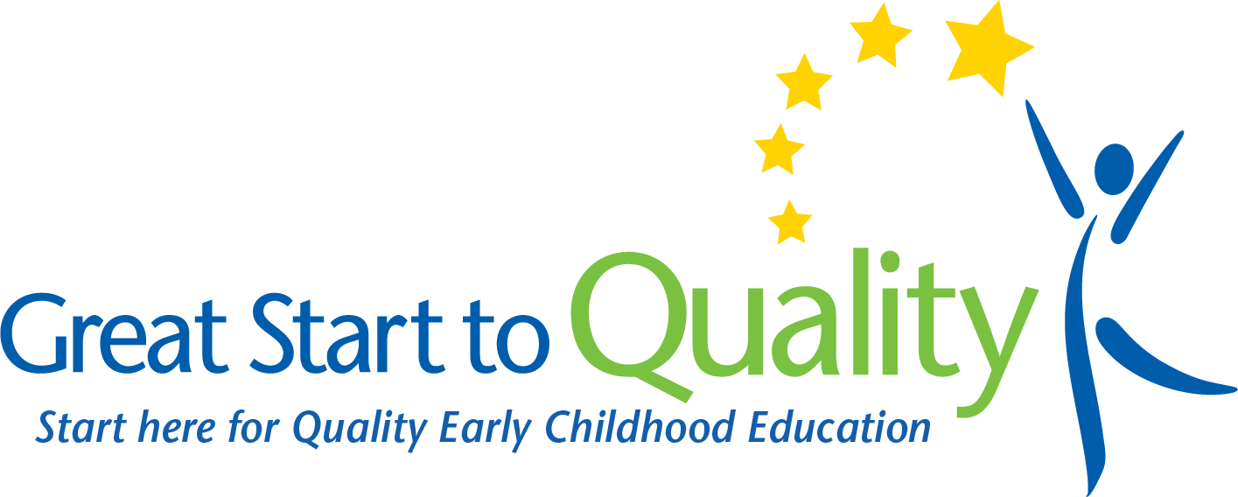

HOW TO USE THE ON-SITE ASSESSMENT SUPPORT DOCUMENT
The following questions can help support program administrators and staff as they reflect on program practices while preparing for the on-site assessment portion of Great Start to Quality. These questions will help programs identify best practices and how to best support the children in care. There are questions for each domain in the Program Quality Assessment (PQA), where staff can think about program practices and how the program can meet, or is meeting, the indicators. Using this document will help with understanding how to include these practices into the program to improve quality but does not guarantee credit on the items in the PQA during the on-site assessment.
This document is intended to support programs as they prepare for their on-site assessment or for help in preparing their program’s Quality Improvement Plan (QIP). Programs can work on one section at a time or complete only those sections that have been identified as opportunities for improvement from a previous on-site assessment. This is not a required document. Programs can choose to complete as much as they feel is necessary to prepare for their on-site assessment or to help complete their program’s QIP.
At the end of the worksheet, there is a section for reflection on the program’s previous on-site assessment results, areas staff may want to focus on for quality improvement, questions program staff may have for Resource Center staff, and an area to list topics of interest that programs may want to learn more about via trainings or professional development.

PROGRAM QUALITY ASSESSMENT TOOL
The School-Age Program Quality Assessment was developed by the David P. Weikart Center. Within the School-Age PQA tool, there are five domains, which include the safe environment, supportive environment, interaction, engagement, and extended observation scales. Providers will learn why each domain in the PQA tool is important and will be provided questions to help staff reflect on the program and best practice in meeting the indicators for each domain.

SAFE ENVIRONMENT
Age-appropriate learning environments are planned with the knowledge of how children learn and develop. In a high-quality school-age program, the physical, social and emotional health, safety, and security of all children should be protected.
Michigan Department of Education’s (MDE) Out-of-School Time Standards of Quality explain best practices about providing a safe environment for children. Please see pages 4-7 and 14-15.
The Program Quality Assessment (PQA) tool provides information about the safe environment domain and its indicators. Please see pages 3-7.

Safe Environment Guiding Questions:
- How has a positive program been promoted that shows respect for, and inclusion of, all children? Click or tap here to enter text.
- How would someone in the program know where to find a first aid kit? How would someone in the program know how to exit the building safely if there were an emergency? Click or tap here to enter text.
- How are the entrances to the program space supervised for safety? Click or tap here to enter text.
- How is the program space arranged so there is good traffic flow and good use of things like sinks, doorways, etc.? Click or tap here to enter text.
- How has the program space been organized so that it is appropriate for all activities offered? Click or tap here to enter text.
- If snacks or drinks are offered, how has the program ensured they are healthy and nutritious? Click or tap here to enter text.

SUPPORTIVE ENVIRONMENT
In a supportive environment, activities are planned to reflect the interests and abilities of the children enrolled. The program offers activities that reflect the mission and goals of the program. A variety of active and quiet activities are offered to the children that are appropriate for their age, skill level, and abilities.
MDE’s Out-of-School Time Standards of Quality explain best practices about providing a supportive environment. Please see pages 16-19.
The Program Quality Assessment (PQA) tool provides information about the supportive environment domain and its indicators. Please see pages 8-13.

Supportive Environment Guiding Questions:
- How are children greeted and interacted with in the program on a daily basis?
- How are the lessons planned, presented, and paced so that each session flows well for the children in the program? Click or tap here to enter text.
- How is active engagement supported in the program? Click or tap here to enter text.
- How is time incorporated in the schedule for children to talk about their activities?
- How are children encouraged to make connections between the activities in the program and their prior knowledge? Click or tap here to enter text.
- How are children supported in building their skills? For instance, how are children encouraged to try new skills or a higher level of performance? If a child is struggling with their results, how is support and encouragement offered? Click or tap here to enter text.
- How are contributions or successes acknowledged in the classroom? Click or tap here to enter text.
- How and when are the children asked questions about the activities they take part in? Click or tap here to enter text.
- If in a permanent, school-aged classroom, how has the classroom been divided into interest areas? Click or tap here to enter text.
- If in a permanent, school-aged classroom, how is children’s work displayed? How are children included in selecting the work to display? Click or tap here to enter text.
- If in a permanent, school-aged classroom, how have all the materials in the program been organized for children to easily access by themselves? Click or tap here to enter text.
- How has time been included in the schedule for children to take part in activities based on their interests? Click or tap here to enter text.

INTERACTION
A quality program provides a safe and respectful environment where children and families may interact in positive ways. Program staff encourage and treat all children with respect and are positive and warm when they interact with the children in their program.
MDE’s Out-of-School Time Standards of Quality explain best practices about interactions with the children in your program. Please see pages 8-9.
The Program Quality Assessment (PQA) tool provides information about the interaction domain and its indicators. Please see pages 15-17.

Interaction Guiding Questions:
- How are children in conflict helped in resolving the conflict? Click or tap here to enter text.
- How are children provided structured opportunities to get to know each other? How is exclusion addressed in the classroom? Click or tap here to enter text.
- How are small group activities provided in the program? How are children provided an opportunity to practice group-process skills? Click or tap here to enter text.
- How are children provided opportunities to lead others? Click or tap here to enter text.
- How do staff work at children’s level and join in with children during activities? Click or tap here to enter text.
- How are children interacted with and talked to in a respectful, positive way? Click or tap here to enter text.
- How is each child in the program guaranteed time where they are interacted with or talked to in every session? Click or tap here to enter text.

ENGAGEMENT
The program should include a variety of activities to meet individual and group needs as well as choices for the children. The children should be offered opportunities to plan and reflect in the classroom.
MDE’s Out-of-School Time Standards of Quality explain best practices about engagement in the classroom. Please see pages 16-19.
The Program Quality Assessment (PQA) tool provides information about the engagement domain and its indicators. Please see pages 18-21.

Engagement Guiding Questions:
- How are children offered a variety of strategies to help them plan? How are children encouraged to share their plans? Click or tap here to enter text.
- How are children offered opportunities to make choices within activities? Click or tap here to enter text.
- How are children offered the chance to reflect on what they have done during the session? Click or tap here to enter text.
- How are children offered the opportunity to give feedback on the program activities? Click or tap here to enter text.
- How are opportunities created for children to take care of their everyday needs and complete routine tasks such as cleaning up, getting supplies, passing out materials, putting up chairs, etc.? Click or tap here to enter text.

EXTENDED OBSERVATION SCALES
The program should demonstrate awareness of students’ individual daily needs, abilities, and learning styles and plan daily activities accordingly.
MDE’s Out-of-School Time Standards of Quality explain best practices about the indicators within the extended observation scales domain. Please see pages 14-19.
The Program Quality Assessment (PQA) tool provides information about the indicators within the extended observation scales domain. Please see pages 22-26.

Extended Observation Scales Guiding Questions:
- What types of activities are offered in the daily schedule? Click or tap here to enter text.
- How are physical activities offered to the children each session? Click or tap here to enter text.
- How are children made aware of the schedule and available activities? Click or tap here to enter text.
- If there is a scheduled time for homework, how are the children supported while they study and learn? Click or tap here to enter text.
- If there is a recreational time offered, how is it supervised and how are the children interacted with during this time? Click or tap here to enter text.
- How are transition times implemented to be smooth and quick? Click or tap here to enter text.
- How are the departure times set up so children know the routine and know what to do while waiting? How are parents/guardians acknowledged and greeted during departure times? Click or tap here to enter text.

QUALITY IMPROVEMENT
The Quality Improvement Plan (QIP) is the tool the Provider and Quality Improvement Consultant (QIC) can use to track goals and growth in Great Start to Quality.
Previous PQA Score (if applicable): Click or tap here to enter text.
Areas of Focus for Quality Improvement: Click or tap here to enter text.
Questions for Quality Improvement Specialist (QIS)/Quality Improvement Consultant (QIC): Click or tap here to enter text.
List of Possible Training/Professional Development Ideas related to Areas of Focus in the QIP: Click or tap here to enter text.

