Great Start to Quality Program Quality Indicators Guidance for Family Child Care with Assistants
October 2020
Funding from the Office of Great Start within the Michigan Department of Education supports the implementation of Great Start.

Introduction
Great Start to Quality is Michigan’s quality rating and improvement system that supports programs, while also helping families find and choose quality programs that meet their children’s needs. There are more than 40 different program quality indicators Great Start to Quality uses to measure the quality of programs. A program quality indicator is a standard used to measure the quality of a program in a specific area. Each program quality indicator falls into one of five categories. These five categories and indicators appear on the Self-Assessment Survey.
The categories on the Self-Assessment Survey are:
- Family and Community Partnerships
- Environment
- Curriculum and Instruction
- Administration and Management
- Staff Qualifications and Professional Development

How to Use the Guidance Document
This document is for planning and reflection purposes only and can help when completing the Self-Assessment Survey. The use of this document does not guarantee that credit will be given for each indicator selected. This document can help organize which documents should be uploaded as evidence or help plan for the rating process. This document is intended to be a working document used throughout the rating process. The guidance document will:
- Help programs understand the indicators
- Help programs understand the intent (purpose/goal) and importance of each indicator
- Give explanations, ideas, and suggestions of what to upload to show the intent of the indicators are being met
Throughout the document a reflection section is provided. In this section, programs can:
- Select whether the program is currently meeting or not currenting meeting the indicator
- Track name and location of documentation, such as where it may be saved
- Make notes of items for improvement, learn more about, and plan for implementation
This document is for planning and reflection purposes only. The use of this document does not guarantee credit will be given for each indicator selected.

Scoring
Throughout the document, the points possible for each indicator on the Self-Assessment Survey are included. As programs use this document, they can track the points they could possibly earn by adding them up. After completing the rating process, the program’s Self-Assessment Survey rating will be calculated on a scale of 1 through 5 Stars.
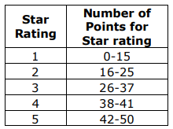
Figure 1 -Points Distribution Chart
The chart shows the range of points needed for each star rating. Please note ratings are not calculated on points alone. For more details about the scoring of the Self-Assessment Survey, please see the Great Start to Quality Program Quality Indicators point distribution document or contact your local Great Start to Quality Resource Center at 1-877-614-7328 for further guidance and support.

General Information
Program Name:
License Number:
MiRegistry Organization ID Number:

MiRegistry Login Information
Email Address:
Password:

Great Start to Quality Login Information
Email Address:
Password:

Star Rating Information
Current Star Rating:
Expiration Date:
Desired Star Rating:
Total Self-Assessment Survey Score:

Support and Resources
Quality Improvement Specialist:
Contact Information:
Quality Improvement Consultant:
Contact Information:

Employment- MiRegistry Tracking
Date:
This section can be used to assure staff have all information in MiRegistry and that it has been Verified. MiRegistry Membership Toolkit contains helpful information on how MiRegistry verifies qualifications and professional development.
Name | Position | Employment Verified on Organization Profile (Y/N) | Qualifications verified by MiRegistry (Y/N) | Professional Development Verified by MiRegistry (Y/N)

A-FP1: Program offers parenting education opportunities
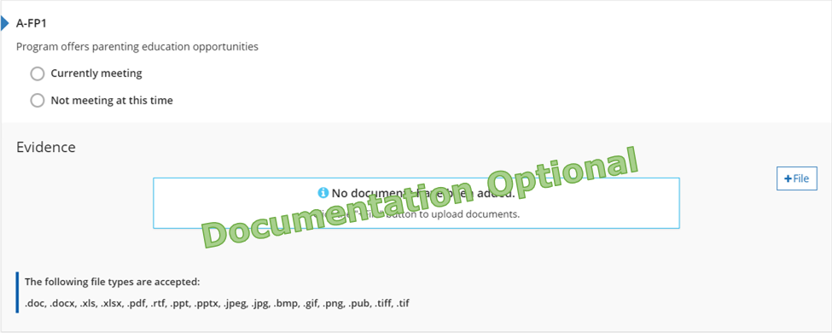
Figure 2. A-FP1 Indicator

Why this Indicator is Important
Families are children’s first teacher, through providing education materials and opportunities families will develop a deeper understanding of children’s development and educational experience.

How a Program May Meet the Intent of the Indicator
☐ Provides information about child development through newsletters and handouts.
☐ Shares learning and training opportunities from program partners.
☐ Shares calendar of events and activities.
☐ Provides family or program handbook(s).
☐ Offers resources on the program’s website.
☐ Hosts curriculum information and events.
☐ Offers professional development opportunities for families.
☐ Other:

Meeting the Indicator
The program has evidence showing or can explain how families are given the chance to get parenting education information and/or information on the different areas of child development.
Michigan’s Early Childhood Standards of Quality
Teachers are qualified to develop and implement a program consistent with the program philosophy and appropriate to the developmental and learning needs of the children and families being served, including the development of a continuing parent education and family involvement component.

Reflection
☐ Currently Meeting
Document Name and Location:
Future Improvements:
☐ Not Currently Meeting
Goal for the future:
What do I want to learn?
Plan for implementation:

Points Possible for Family Partnerships (0, 2, or 4 pts.)
- Program has 0-1 of the indicators in place (0 pts.)
- Program has 2-3 of the indicators in place (2 pts.)
- Program has all 4 of the indicators in place (4 pts.)

A-FP2: Provider/educator engages in informal communication with parents
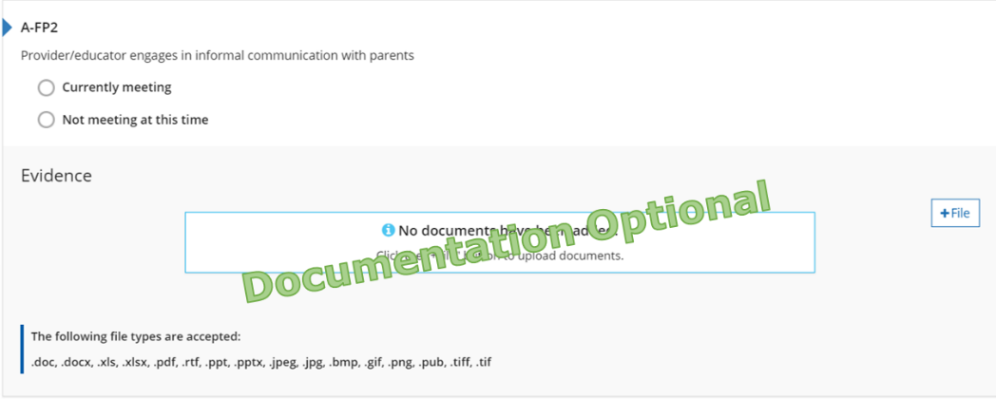
Figure 3. A-FP2 Indicator

Why this Indicator is Important
When staff interact informally with families, they support the development of an on-going relationship. Through sharing information about the child’s development and involvement in the program it keeps families involved in their child’s education.

How a Program May Meet the Intent of the Indicator
☐ Provides information about the child’s day to families.
☐ Shares options for communication between administrators, educators, and families.
☐ Provides information about upcoming events through newsletters and handouts.
☐ Shares calendar of events and activities.
☐ Provides family or program handbook(s).
☐ How anecdotal notes or observations are shared and discussed with families.
☐ Other:

Meeting the Indicator
The program has evidence showing how the staff communicate with families about their child’s day during pick up, drop off, and throughout the day.
Michigan’s Early Childhood Standards of Quality
Families have multiple opportunities for regular involvement with the program and its staff including placement, planning for individualization and evaluation related specifically to their child.

Reflection
☐ Currently Meeting
Document Name and Location:
Future Improvements:
☐ Not Currently Meeting
Goal for the future:
What do I want to learn?
Plan for implementation:

Points Possible for Family Partnerships (0, 2, or 4 pts.)
- Program has 0-1 of the indicators in place (0 pts.)
- Program has 2-3 of the indicators in place (2 pts.)
- Program has all 4 of the indicators in place (4 pts.)

A-FP3: Provider engages in formal communication (i.e., parent/teacher conferences, home visits) to inform parents of children’s developmental progress
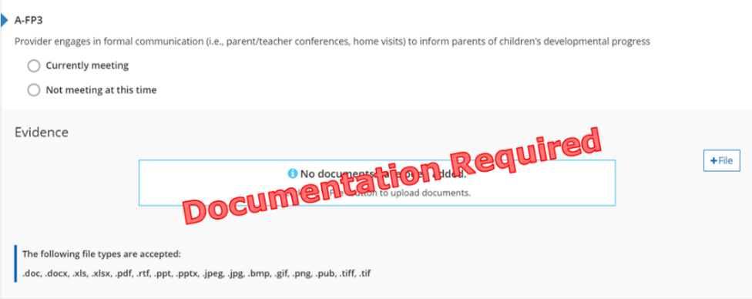
Figure 4. A-FP3 Indicator

Why this Indicator is Important
When staff interact formally with families, they support the development of an on-going relationship. Through sharing detailed information about the child’s development, staff support and encourage families to collaborate on goals and desired outcomes for the child.

How a Program May Meet the Intent of the Indicator
☐ Provides scheduling options for parent-teacher conferences or home visits.
☐ Shares learning objectives for child assessment tools.
☐ Provides family or program handbook(s) with parent-teacher conferences or home visit policy.
☐ Other:

Meeting the Indicator
The program has evidence showing conferences and/or home visits are offered to the families of all children, no matter the child’s age or classroom.
Michigan’s Early Childhood Standards of Quality
Families have multiple opportunities for regular involvement with the program and its staff including placement, planning for individualization and evaluation related specifically to their child.

Reflection
☐ Currently Meeting
Document Name and Location:
Future Improvements:
☐ Not Currently Meeting
Goal for the future:
What do I want to learn?
Plan for implementation:

Points Possible for Family Partnerships (0, 2, or 4 pts.)
- Program has 0-1 of the indicators in place (0 pts.)
- Program has 2-3 of the indicators in place (2 pts.)
- Program has all 4 of the indicators in place (4 pts.)

A-FP4: Communication, education, and informational materials and opportunities for families are delivered in a way that meets their diverse needs (e.g., literacy level, language, cultural appropriateness, etc.)
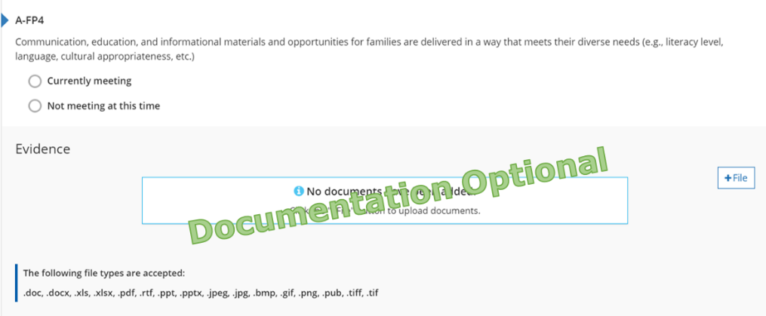
Figure 5. A-FP4 Indicator

Why this Indicator is Important
By providing families with information and/or resources in ways that meet their individual needs; staff ensure all families are included in programming.

How a Program May Meet the Intent of the Indicator
☐ Provides information in multiple languages.
☐ Shares resources for translation.
☐ Collects family survey or enrollment materials that include options for communication preferences.
☐ Provides family or program handbook(s) with a policy on different family structures and various modes of communication.
☐ Shares statement or policy on communicating with various family members or guardians.
☐ Other:

Meeting the Indicator
The program has evidence showing how staff communicate with families in a way that meets their individual needs/preferences.
Michigan’s Early Childhood Standards of Quality
The program’s policies and practices promote support and respect for the home language, culture, and family composition of each child in ways that support the child’s health, learning, and social-emotional well-being.

Reflection
☐ Currently Meeting
Document Name and Location:
Future Improvements:
☐ Not Currently Meeting
Goal for the future:
What do I want to learn?
Plan for implementation:

Points Possible for Family Partnerships (0, 2, or 4 pts.)
- Program has 0-1 of the indicators in place (0 pts.)
- Program has 2-3 of the indicators in place (2 pts.)
- Program has all 4 of the indicators in place (4 pts.)
Total points for Family Partnership Section:

A-CP1: Partnerships to provide or connect families to appropriate comprehensive services
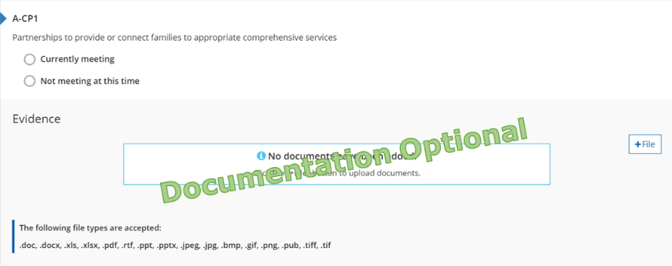
Figure 6. A-CP1 Indicator

Why this Indicator is Important
Connecting families with public/private community agencies supports the needs of, and awareness of, available resources. Ensuring families and children have their basic needs met allows for optimal development and growth.

How a Program May Meet the Intent of the Indicator
☐ Provides opportunities to meet with families to discuss concerns or questions about the child’s development.
☐ Shares information on local and community resources.
☐ Shares handouts and contact information for local businesses.
☐ Provides family or program handbook(s) with policy on how referrals are made.
☐ Other:

Meeting the Indicator
The program has evidence showing how staff help refer families to, and access services they need.
Michigan’s Early Childhood Standards of Quality
The program works with public and private community agencies and educational institutions to meet the comprehensive needs of children and families, to assist one another in the delivery of services, increase resources, and to strengthen advocacy efforts.

Reflection
☐ Currently Meeting
Document Name and Location:
Future Improvements:
☐ Not Currently Meeting
Goal for the future:
What do I want to learn?
Plan for implementation:

Points Possible for Community Partnerships (0, 2, or 4 pts.)
- Program has 0-1 of the indicators in place (0 pts.)
- Program has 2 of the indicators in place (2 pts.)
- Program has all 3 of the indicators in place (4 pts.)

A-CP2: Partnerships that take basic steps to facilitate children’s transition between and among programs, agencies and schools
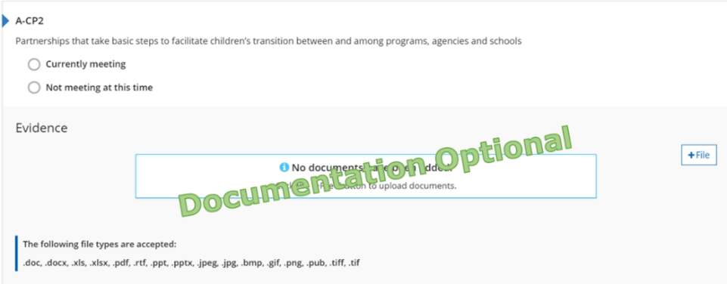
Figure 7. A-CP2 Indicator

Why this Indicator is Important
To provide quality continuity of care, program staff work cooperatively and collaboratively with community organizations, schools, and programs to ease children’s transitions. Partnerships and communication between all agencies allow for the social/emotional development of children served.

How a Program May Meet the Intent of the Indicator
☐ Provides opportunities for children and families to meet staff prior to transitioning into the program.
☐ Shares information about transitions and how to ease the stress of transitioning.
☐ Shares information on other preschool options and local kindergarten(s).
☐ Provides family or program handbook(s) with policies on transitions including; into the program, other preschools, or kindergarten.
☐ Other:

Meeting the Indicator
The program has evidence showing how staff help children transition into and out of the program.
Michigan’s Early Childhood Standards of Quality
The program works cooperatively and collaboratively with other early childhood programs in the community in order to facilitate children’s transition into and out of programs and from one program to another.

Reflection
☐ Currently Meeting
Document Name and Location:
Future Improvements:
☐ Not Currently Meeting
Goal for the future:
What do I want to learn?
Plan for implementation:

Points Possible for Community Partnerships (0, 2, or 4 pts.)
- Program has 0-1 of the indicators in place (0 pts.)
- Program has 2 of the indicators in place (2 pts.)
- Program has all 3 of the indicators in place (4 pts.)

A-CP3: Participation in community associations
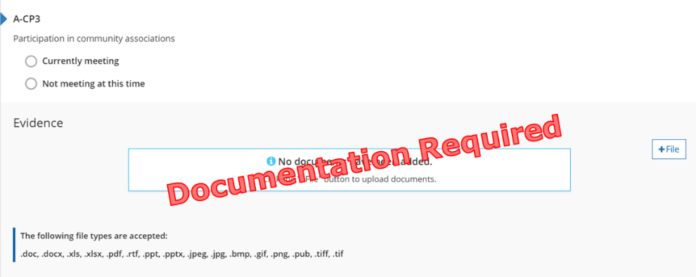
Figure 8. A-CP3 Indicator

Why this Indicator is Important
Partnering with other professional educational organizations allows programs to enhance its services to children and families through evidence-based research.

How a Program May Meet the Intent of the Indicator
☐ Provides meeting agenda, meeting minutes, or membership from local or professional organization.
☐ Obtains local or national professional membership.
☐ Provides proof of attendance to local infant toddler learning community.
☐ Provides proof that 50% of staff members are members of MiRegistry.
☐ Other:

Meeting the Indicator
The program has evidence showing how it or a staff member, is currently participating with a professional organization to enhance the program’s early childhood or business practices.
Michigan’s Early Childhood Standards of Quality
The early childhood specialist and/or program administrator participates in continuing education/professional development activities.

Reflection
☐ Currently Meeting
Document Name and Location:
Future Improvements:
☐ Not Currently Meeting
Goal for the future:
What do I want to learn?
Plan for implementation:

Points Possible for Community Partnerships (0, 2, or 4 pts.)
- Program has 0-1 of the indicators in place (0 pts.)
- Program has 2 of the indicators in place (2 pts.)
- Program has all 3 of the indicators in place (4 pts.)
Total points for Community Partnership Section:

A-PE1: Program is in a physical location that is free of environmental risks (e.g., lead, mercury, asbestos and indoor air pollutants)
Figure 9. A-PE1 Indicator

Why this Indicator is Important
Program facility is safe, secure, and complies with the child care licensing requirements of Michigan.

How a Program May Meet the Intent of the Indicator
☐ Provides a safe and clean environment.
☐ Program follows licensing requirements.

Meeting the Indicator
The program is in good standing with licensing.
- This is verified by Great Start to Quality staff during the rating process.
- No additional evidence is required.
Michigan’s Early Childhood Standards of Quality
Programs address requirements for continuous safe environments for children.

Reflection
☐ Currently Meeting
Document Name and Location:
Future Improvements:
☐ Not Currently Meeting
Goal for the future:
What do I want to learn?
Plan for implementation:

Points Possible for Physical Environment (0 or 2 pts.)
- Program has a safe physical environment in place (2 pts.)
Total points for Physical Environment Section:

A-R1: Program demonstrates that it has smaller group size and better teacher:child ratio than required by licensing
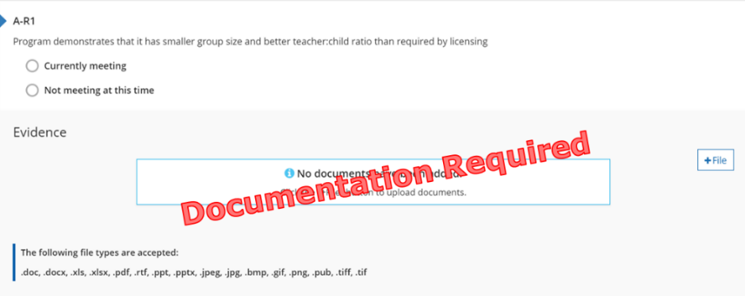
Figure 10. A-R1 Indicator

Why this Indicator is Important
Having more staff and fewer children than required by licensing creates a higher quality learning environment for children. This ensures staff have more one-on-one time with each child.

How a Program May Meet the Intent of the Indicator
☐ Provides evidence of lower staff to child ratios than required by licensing.
☐ Shares information with families about the importance of low ratios.
☐ Provides enrollment information including number of children and staff.
☐ Shares family or program handbook(s) with policy on program ratios.
☐ Other:

Meeting the Indicator
The program has evidence showing the program always maintain better ratios than required by licensing.
Michigan’s Early Childhood Standards of Quality
Formal and informal grouping practices are used to strengthen children’s learning.

Reflection
☐ Currently Meeting
Document Name and Location:
Future Improvements:
☐ Not Currently Meeting
Goal for the future:
What do I want to learn?
Plan for implementation:

Points Possible for Ratios (0 or 2 pts.)
- Program has evidence of ratios in place (2 pts.)
Total points for Ratios Section:

A-HE1: Nutrition Information
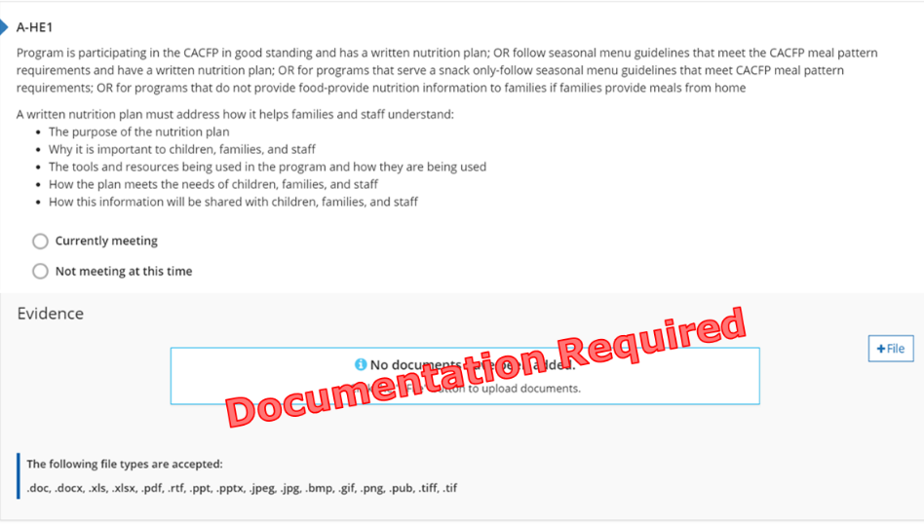
Figure 11. A-HE1 Indicator

Why this Indicator is Important
Nutrition is an important part of leading a healthy lifestyle. Understanding how nutrition supports the physical and mental well-being of children ensures they are prepared to actively learn and engage in school.

How a Program May Meet the Intent of the Indicator
A written nutrition plan must address how it helps families and staff understand:
- The purpose of the nutrition plan.
- Why it is important to children, families, and staff.
- The tools and resources being used in the program and how they are being used.
- How the plan meets the needs of children, families, and staff.
- How this information will be shared with children, families, and staff.
Nutrition plans are not required when the program ONLY serves snack OR if the program does NOT provide food.

Meeting the Indicator
Program provides food- has a written nutrition plan AND participates with CACFP or follows CACFP menu guidelines
Program ONLY provides snack- follows CACFP menu guidelines
Program does NOT provide food- provides nutrition information to families if families provide meals
Michigan’s Early Childhood Standards of Quality
Healthy Eating. Children become aware of and begin to develop nutritional habits that contribute to good health.

Reflection
☐ Currently Meeting
Document Name and Location:
Future Improvements:
☐ Not Currently Meeting
Goal for the future:
What do I want to learn?
Plan for implementation:

Points Possible for Health Environment (0, 2, or 4 pts.)
- Program has 0-1 of the indicators in place (0 pts.)
- Program has 2-3 of the indicators in place (2 pts.)
- Program has 4-5 of the indicators in place (4 pts.)

A-HE2: 30 minutes of every 3 hours dedicated to active outdoor time, with appropriate indoor physical activities available when weather prohibits outdoor play
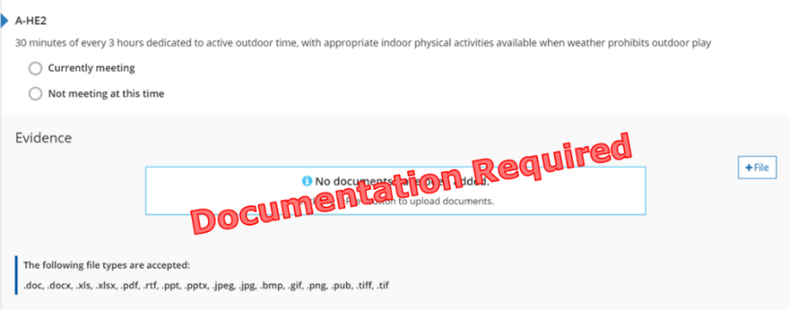
Figure 12. A-HE2 Indicator

Why this Indicator is Important
The outdoor natural learning environment is an extension of the classroom. It ensures children have access to seek out exercise, fresh air, and offers opportunities to learn and care for their local community and environment.

Formula
Total number of class minutes multiplied by .166 = the minimum number of minutes required for outdoor time.

How a Program May Meet the Intent of the Indicator
☐ Provides a daily schedule that includes outdoor time.
☐ Shares options to active play when weather permits outdoor time.
☐ Shares information about the benefits of active plan and outdoor time.
☐ Provides family or program handbook(s) with information about outdoor play space and times.
☐ Other:

Meeting the Indicator
The program has evidence it has 30 minutes of outside time for every 3 hours it is open.
Michigan’s Early Childhood Standards of Quality
The outdoor physical space is safe and allows for individual activities and social interactions.

Reflection
☐ Currently Meeting
Document Name and Location:
Future Improvements:
☐ Not Currently Meeting
Goal for the future:
What do I want to learn?
Plan for implementation:

Points Possible for Health Environment (0, 2, or 4 pts.)
- Program has 0-1 of the indicators in place (0 pts.)
- Program has 2-3 of the indicators in place (2 pts.)
- Program has 4-5 of the indicators in place (4 pts.)

A-HE3: Provisions for reviewing and updating health records according to the most recent Early, Periodic Screening, Diagnosis and Treatment (EPSDT) schedule for infants, and reviewing and updating records for toddlers and older children annually
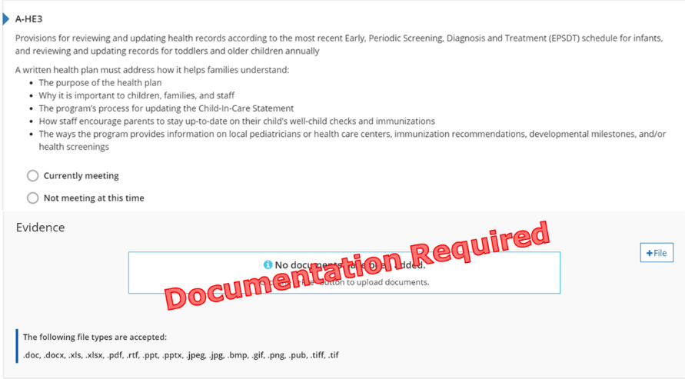
Figure 13. A-HE3 Indicator

Why this Indicator is Important
Maintaining a process for tracking and updating health information is in place and for communicating the recommendations to families encourages all children are regularly seen by a health care provider to maintain optimal health and development.

How a Program May Meet the Intent of the Indicator
A written health plan must address how it helps families understand:
- The purpose of the health plan.
- Why it is important to children, families, and staff.
- The program’s process for updating the Child-In-Care Statement.
- How staff encourage parents to stay up-to-date on their child’s well-child checks and immunizations.
- The ways the program provides information on local pediatricians or health care centers, immunization recommendations, developmental milestones, and/or health screenings.

Meeting the Indicator
The program has evidence of a written health plan.
Michigan’s Early Childhood Standards of Quality
Programs address the need for continuous accessible health care (mental, oral, physical health, and fitness) for children.

Reflection
☐ Currently Meeting
Document Name and Location:
Future Improvements:
☐ Not Currently Meeting
Goal for the future:
What do I want to learn?
Plan for implementation:

Points Possible for Health Environment (0, 2, or 4 pts.)
- Program has 0-1 of the indicators in place (0 pts.)
- Program has 2-3 of the indicators in place (2 pts.)
- Program has 4-5 of the indicators in place (4 pts.)

A-HE4: A process for observing each child’s health and development on a daily basis and communicating observations to the child’s family, other provider/educators, and to specialized staff, with recommendations for family to seek medical opinions as necessary
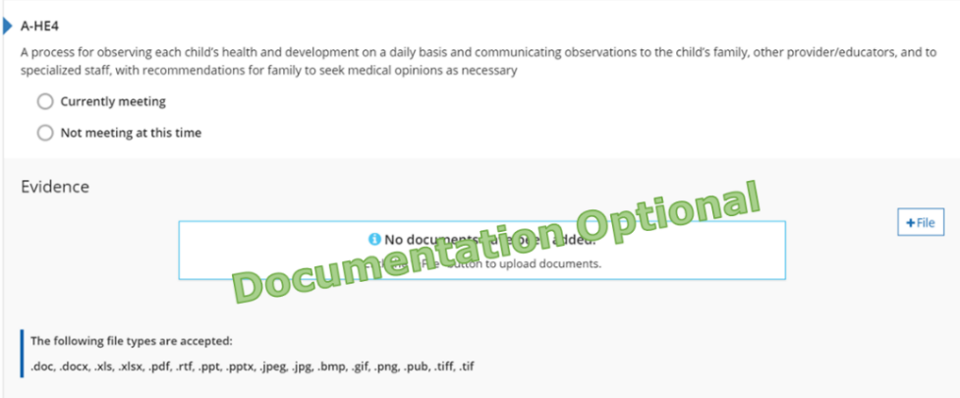
Figure 14. A-HE4 Indicator

Why this Indicator is Important
Program staff observe children’s health and well-being and communicate consistently with families about their observations. This ensure collaboration among families and staff to address children’s overall health and well-being.

How a Program May Meet the Intent of the Indicator
☐ Provides evidence of daily health logs or incident reports.
☐ Shares information with families about children’s health on a daily basis.
☐ Provides evidence of how staff communicate with family members relating to the child’s health.
☐ Provides family or program handbook(s) with ways policy on children and staff illness and exclusion.
☐ Other:

Meeting the Indicator
The program has evidence of how staff share information about a child’s daily health, observations, and concerns with families.
Michigan’s Early Childhood Standards of Quality
Programs address the need for continuous accessible health care (mental, oral, physical health, and fitness) for children.

Reflection
☐ Currently Meeting
Document Name and Location:
Future Improvements:
☐ Not Currently Meeting
Goal for the future:
What do I want to learn?
Plan for implementation:

Points Possible for Health Environment (0, 2, or 4 pts.)
- Program has 0-1 of the indicators in place (0 pts.)
- Program has 2-3 of the indicators in place (2 pts.)
- Program has 4-5 of the indicators in place (4 pts.)

A-HE5: A regular oral care routine, including tooth brushing and/or gum wiping (for infants) at least once per day
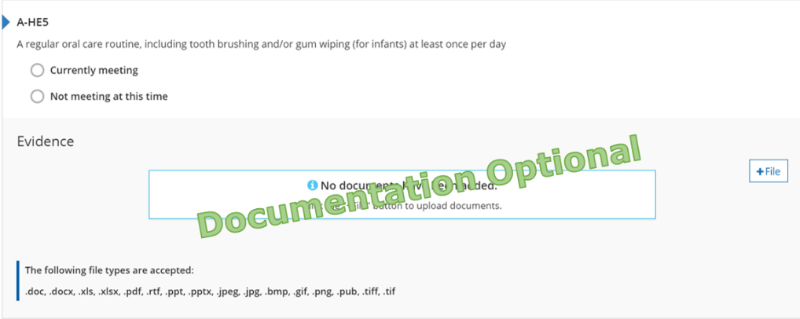
Figure 15. A-HE5 Indicator

Why this Indicator is Important
Oral care routines encourage and reinforce healthy habits and prevent gingivitis and tooth decay.

How a Program May Meet the Intent of the Indicator
☐ Provides opportunities for tooth brushing or gum wiping to all children once per day.
☐ Provides evidence of oral care included in the program’s daily schedule.
☐ Provides family or program handbook(s) with information on the program’s oral care routine.
☐ Other:

Meeting the Indicator
The program has evidence of an oral care routine for all children.
Michigan’s Early Childhood Standards of Quality
Programs address the need for continuous accessible health care (mental, oral, physical health, and fitness) for children.

Reflection
☐ Currently Meeting
Document Name and Location:
Future Improvements:
☐ Not Currently Meeting
Goal for the future:
What do I want to learn?
Plan for implementation:

Points Possible for Health Environment (0, 2, or 4 pts.)
- Program has 0-1 of the indicators in place (0 pts.)
- Program has 2-3 of the indicators in place (2 pts.)
- Program has 4-5 of the indicators in place (4 pts.)
Total points for Health Environment Section:

A-CI1: A statement of educational and developmental priorities for the children
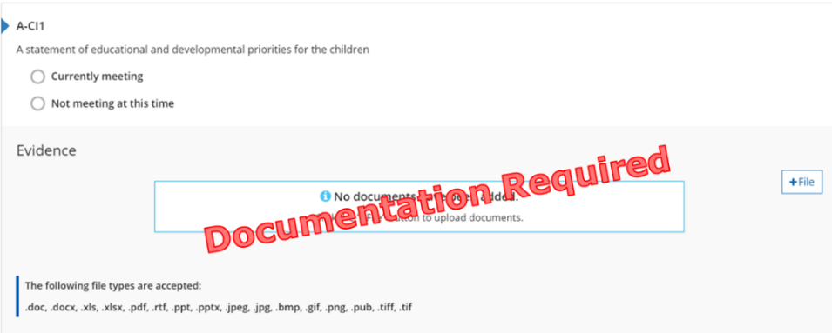
Figure 16. A-CI1 Indicator

Why this Indicator is Important
The program’s mission/vision statement informs families and about their beliefs about how they serve the children and families involved in the program.

How a Program May Meet the Intent of the Indicator
☐ Shares written mission, philosophy, or vision statement.
☐ Provides family or program handbook(s) with mission or philosophy statement.
☐ Other:

Meeting the Indicator
The program has evidence of its mission and/or philosophy statement.
Michigan’s Early Childhood Standards of Quality
A written philosophy statement for the early childhood care and education program is developed and utilized as the basis for making program decisions and establishing program goals and objectives.

Reflection
☐ Currently Meeting
Document Name and Location:
Future Improvements:
☐ Not Currently Meeting
Goal for the future:
What do I want to learn?
Plan for implementation:

Points Possible for Curriculum and Instruction (0, 2, 4, or 6 pts.)
- Program has 0-1 of the indicators in place (0 pts.)
- Program has 2 of the indicators in place (2 pts.)
- Program has 3-4 of the indicators in place (4 pts.)
- Program has all 5 of the indicators in place (6 pts.)

A-CI2: A routine daily schedule that is predictable yet flexible; includes time for transition; includes indoor and outdoor activities and is responsive to each child’s need to be active or resting
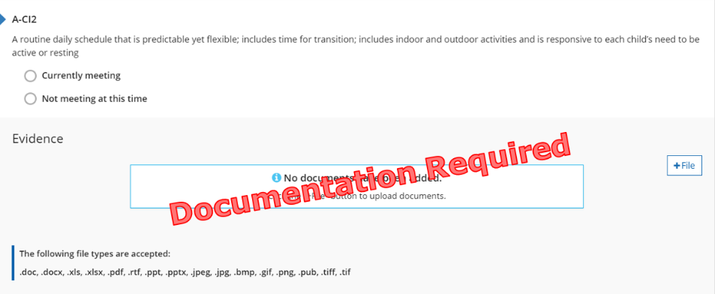
Figure 17. A-CI2 Indicator

Why this Indicator is Important
Consistent daily routines provide children a sense of comfort and safety in knowing what will happen next and learn to trust that caring adults will provide what they need.

How a Program May Meet the Intent of the Indicator
☐ Provides a daily schedule that includes:
- Time for transition
- Meal times
- Bodily care routines
- Indoor and outdoor activities
- Is responsive to each child’s need to be active or resting
☐ Other:

Meeting the Indicator
The program has evidence of the current daily schedule.
Michigan’s Early Childhood Standards of Quality
The daily routine/schedule is predictable, yet flexible.

Reflection
☐ Currently Meeting
Document Name and Location:
Future Improvements:
☐ Not Currently Meeting
Goal for the future:
What do I want to learn?
Plan for implementation:

Points Possible for Curriculum and Instruction (0, 2, 4, or 6 pts.)
- Program has 0-1 of the indicators in place (0 pts.)
- Program has 2 of the indicators in place (2 pts.)
- Program has 3-4 of the indicators in place (4 pts.)
- Program has all 5 of the indicators in place (6 pts.)

A-CI3: An approved curriculum
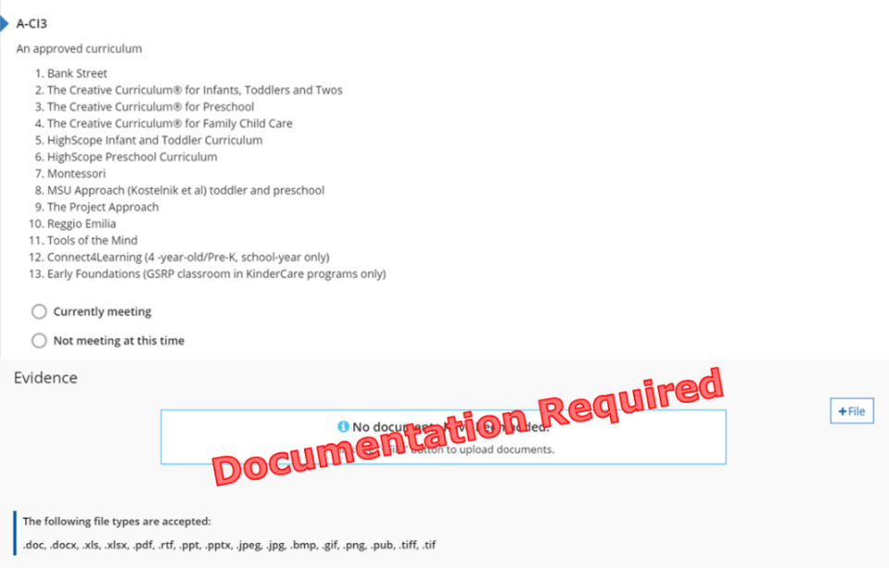
Figure 18. A-CI3 Indicator

Why this Indicator is Important
Approved curricula provide staff with a guide based on research and best practices to scaffold children’s development and learning.

How a Program May Meet the Intent of the Indicator
☐ Provides evidence of the curriculum implemented and the age groups served.
☐ Shares learning objectives of the curriculum.
☐ Provides family or program handbook(s) with curriculum information.
☐ Offers trainings or family nights on the curriculum model used.
☐ Other:

Meeting the Indicator
The program has evidence showing the use of a comprehensive, age appropriate, curriculum in the program that is on Great Start to Quality’s approved curriculum list.
Michigan’s Early Childhood Standards of Quality
The curriculum is designed to address all aspects of children’s development and to further their learning with emphasis on the unique needs of the young child.

Reflection
☐ Currently Meeting
Document Name and Location:
Future Improvements:
☐ Not Currently Meeting
Goal for the future:
What do I want to learn?
Plan for implementation:

Points Possible for Curriculum and Instruction (0, 2, 4, or 6 pts.)
- Program has 0-1 of the indicators in place (0 pts.)
- Program has 2 of the indicators in place (2 pts.)
- Program has 3-4 of the indicators in place (4 pts.)
- Program has all 5 of the indicators in place (6 pts.)

A-CI4: A written plan for integrating policies, procedures and practices that reflects a respect and valuing of children’s culture and demonstrates cultural competence
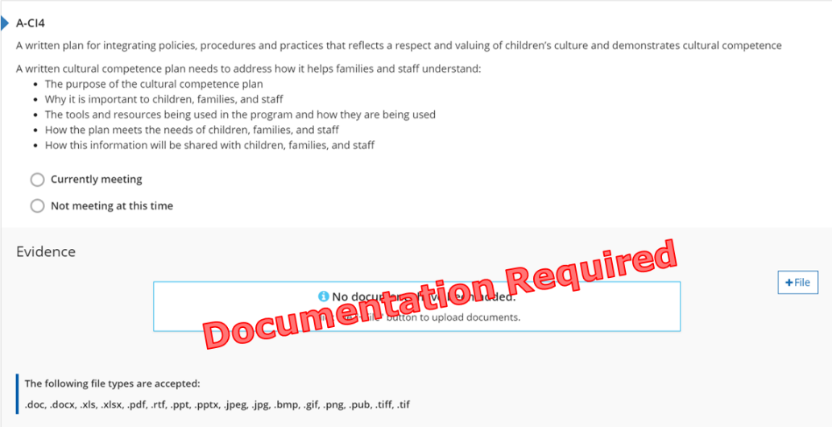
Figure 19. A-CI4 Indicator

Why this Indicator is Important
Staff provide opportunities to identify and celebrate the diversity of children’s families, community and other cultures. This encourages increased self-esteem, pride in one’s culture, and feelings of acceptance of all cultures to become global citizens.

How a Program May Meet the Intent of the Indicator
A written cultural competence plan must address how it helps families and staff understand:
- The purpose of the cultural competence plan.
- Why it is important to children, families, and staff.
- The tools and resources being used in the program and how they are being used.
- How the plan meets the needs of children, families, and staff.
- How this information will be shared with children, families, and staff.

Meeting the Indicator
The program has evidence of a written cultural competence plan.
Michigan’s Early Childhood Standards of Quality
The program’s policies and practices support the enrollment and participation of all children including those with disabilities and promote an environment of acceptance that supports and respects gender, culture, language, ethnicity, individual capacities, and family composition.

Reflection
☐ Currently Meeting
Document Name and Location:
Future Improvements:
☐ Not Currently Meeting
Goal for the future:
What do I want to learn?
Plan for implementation:

Points Possible for Curriculum and Instruction (0, 2, 4, or 6 pts.)
- Program has 0-1 of the indicators in place (0 pts.)
- Program has 2 of the indicators in place (2 pts.)
- Program has 3-4 of the indicators in place (4 pts.)
- Program has all 5 of the indicators in place (6 pts.)

A-CI5: A written plan for serving children with special needs
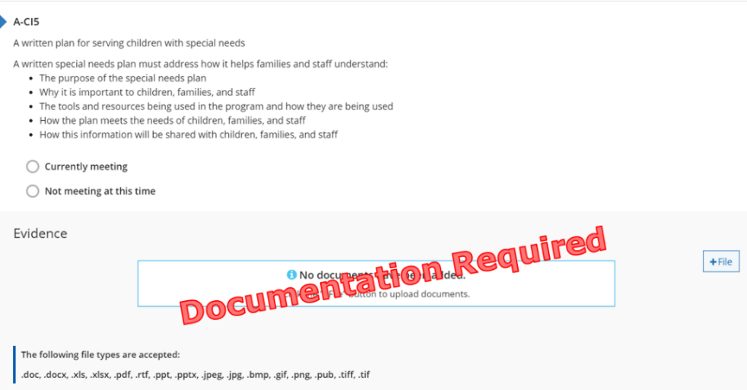
Figure 20. A-CI5 Indicator

Why this Indicator is Important
Staff provide opportunities to identify, support, and learn about the different learning styles and abilities of children, families, and community members. This increases self-esteem, understanding of differences, and feelings of acceptance of all abilities.

How a Program May Meet the Intent of the Indicator
A written special needs plan must address how it helps families and staff understand:
- The purpose of the special needs plan.
- Why it is important to children, families, and staff.
- The tools and resources being used in the program and how they are being used.
- How the plan meets the needs of children, families, and staff.
- How this information will be shared with children, families, and staff.

Meeting the Indicator
The program has evidence of a written special needs plan.
Michigan’s Early Childhood Standards of Quality
The program’s policies and practices support the enrollment and participation of all children including those with disabilities and promote an environment of acceptance that supports and respects gender, culture, language, ethnicity, individual capacities, and family composition.

Reflection
☐ Currently Meeting
Document Name and Location:
Future Improvements:
☐ Not Currently Meeting
Goal for the future:
What do I want to learn?
Plan for implementation:

Points Possible for Curriculum and Instruction (0, 2, 4, or 6 pts.)
- Program has 0-1 of the indicators in place (0 pts.)
- Program has 2 of the indicators in place (2 pts.)
- Program has 3-4 of the indicators in place (4 pts.)
- Program has all 5 of the indicators in place (6 pts.)
Total points for Curriculum and Instruction Section:

A-SA1: Lead provider/educator discusses anecdotal notes/observations as a basis for working/teaching with each child
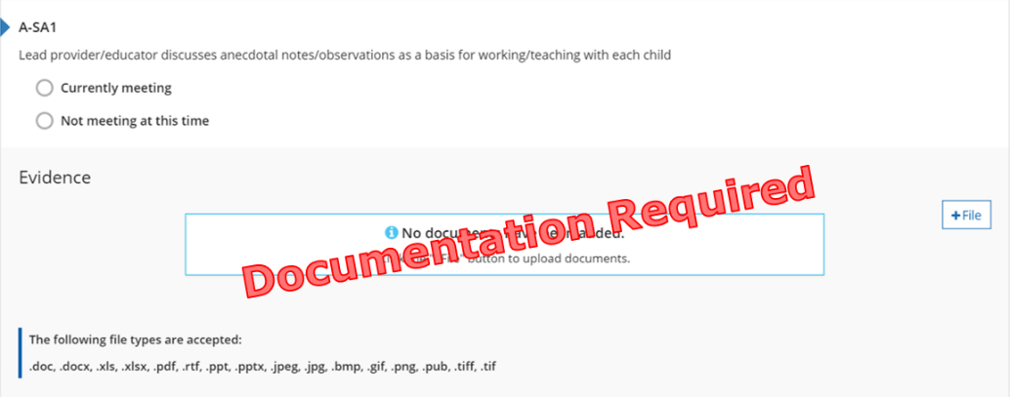
Figure 21. A-SA1 Indicator

Why this Indicator is Important
Anecdotal notes allow staff to track and plan for children’s learning based on evidence of where the child is developmentally and encourages two-way communication between staff and families.

How a Program May Meet the Intent of the Indicator
☐ Provides example of anecdotal notes/observations.
☐ Shares forms used to record anecdotal notes/observations.
☐ Provides family or program handbook(s) with policy about anecdotal notes/observations.
☐ Offers trainings for staff on the importance and/or program procedures for recording anecdotal notes/observations.
☐ Other:

Meeting the Indicator
The program has evidence showing notes/observations are taken in the program as a tool for working with and planning for each child.
Michigan’s Early Childhood Standards of Quality
The program uses information gained from a variety of child assessment measures to plan learning experiences for individual children and groups.

Reflection
☐ Currently Meeting
Document Name and Location:
Future Improvements:
☐ Not Currently Meeting
Goal for the future:
What do I want to learn?
Plan for implementation:

Points Possible for Screening and Assessment (0, 2, 4, or 6 pts.)
- Program has 0-1 of the indicators in place (0 pts.)
- Program has 2-3 of the indicators in place (2 pts.)
- Program has 4 of the indicators in place (4 pts.)
- Program has all 5 of the indicators in place (6 pts.)

A-SA2: Complete annual developmental screening on each child
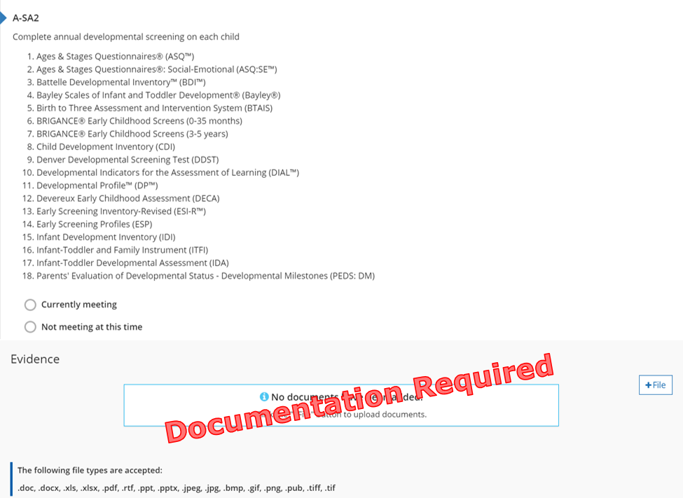
Figure 22. A-SA2 Indicator

Why this Indicator is Important
Implementing an approved screening tool allows for staff to collect point in time data that provides information about the child’s physical, cognitive, and social-emotional health. Staff use data to identify possible developmental delays and behavioral problems and share the results with families.

How a Program May Meet the Intent of the Indicator
☐ Provides evidence of the screening tool implemented and the age groups served.
☐ Provides family or program handbook(s) with screening tool information.
☐ Shares calendar of screening completion schedules.
☐ Other:

Meeting the Indicator
The program has evidence showing the use of an age appropriate screening tool (a tool used to check for any concerns about a child’s development) on all children that is on Great Start to Quality’s approved screening list.
Michigan’s Early Childhood Standards of Quality
The program uses information gained from a variety of child assessment measures to plan learning experiences for individual children and groups.

Reflection
☐ Currently Meeting
Document Name and Location:
Future Improvements:
☐ Not Currently Meeting
Goal for the future:
What do I want to learn?
Plan for implementation:

Points Possible for Screening and Assessment (0, 2, 4, or 6 pts.)
- Program has 0-1 of the indicators in place (0 pts.)
- Program has 2-3 of the indicators in place (2 pts.)
- Program has 4 of the indicators in place (4 pts.)
- Program has all 5 of the indicators in place (6 pts.)

A-SA3: Uses an approved child assessment tool at least two times a year
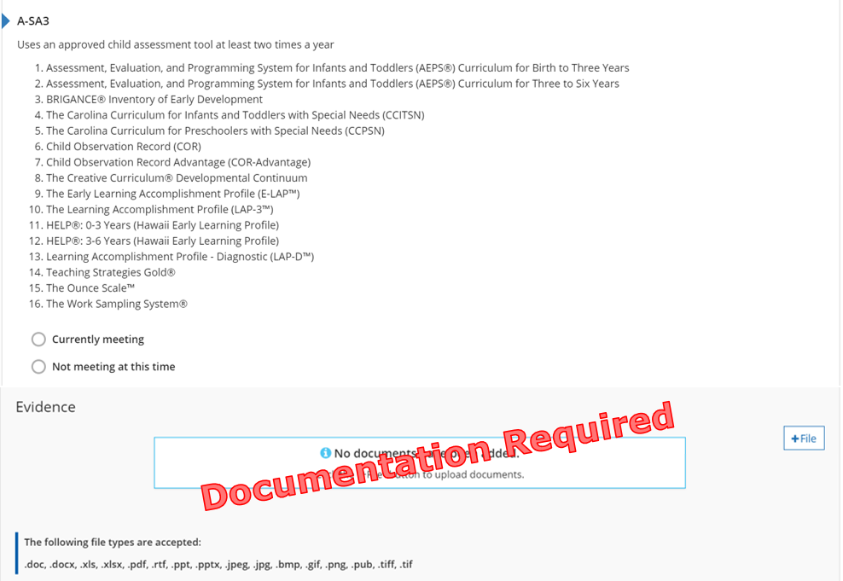
Figure 23. A-SA3 Indicator

Why this Indicator is Important
Implementing an approved assessment tool allows staff to collect ongoing data about the child’s developmental progress ensuring instruction and content meet the developmental needs of each child.

How a Program May Meet the Intent of the Indicator
☐ Provides evidence of the assessment tool implemented and the age groups served.
☐ Provides family or program handbook(s) with assessment tool information.
☐ Shares calendar of assessment completion schedules.
☐ Other:

Meeting the Indicator
The program has evidence showing the use of an age appropriate assessment tool on all children that is on the Great Start to Quality approved assessment list.
Michigan’s Early Childhood Standards of Quality
The program uses appropriate assessment tools to help identify children who may require additional specialized programs and interventions.

Reflection
☐ Currently Meeting
Document Name and Location:
Future Improvements:
☐ Not Currently Meeting
Goal for the future:
What do I want to learn?
Plan for implementation:

Points Possible for Screening and Assessment (0, 2, 4, or 6 pts.)
- Program has 0-1 of the indicators in place (0 pts.)
- Program has 2-3 of the indicators in place (2 pts.)
- Program has 4 of the indicators in place (4 pts.)
- Program has all 5 of the indicators in place (6 pts.)

A-SA4: Uses child assessment results in parent-teacher conferences at least two times a year
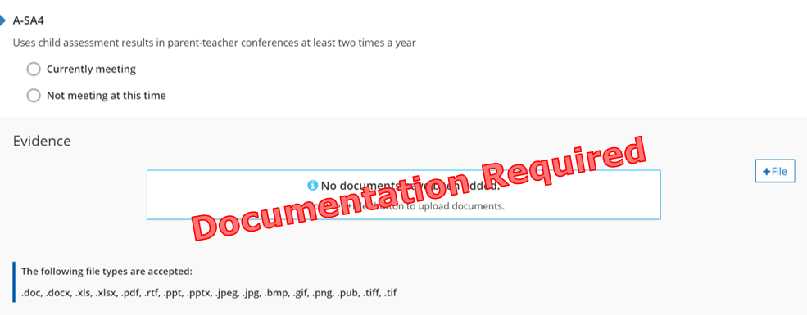
Figure 24. A-SA4 Indicator

Why this Indicator is Important
Documenting a child’s developmental progress over time allows for staff and families to use data to discuss the child’s development, create individualize short- and long-term instructional goals for the child, and to bridge the gap between at home and on-site learning.

How a Program May Meet the Intent of the Indicator
☐ Provides scheduling options for parent-teacher conferences or home visits two times a year based on assessment results.
☐ Shares calendar of parent-teacher conference/home visit schedules.
☐ Provides family or program handbook(s) with parent-teacher conferences or home visit policy.
☐ Other:
A Great Start to Quality Approved Assessment tool must be implemented twice per year to receive credit for this indicator.

Meeting the Indicator
The program has evidence showing how they share children’s assessment results with families.
Michigan’s Early Childhood Standards of Quality
Families have multiple opportunities for regular involvement with the program and its staff including placement, planning for individualization and evaluation related specifically to their child.

Reflection
☐ Currently Meeting
Document Name and Location:
Future Improvements:
☐ Not Currently Meeting
Goal for the future:
What do I want to learn?
Plan for implementation:

Points Possible for Screening and Assessment (0, 2, 4, or 6 pts.)
- Program has 0-1 of the indicators in place (0 pts.)
- Program has 2-3 of the indicators in place (2 pts.)
- Program has 4 of the indicators in place (4 pts.)
- Program has all 5 of the indicators in place (6 pts.)

A-SA5: Uses assessment to inform individual, small group and whole group instruction and interaction
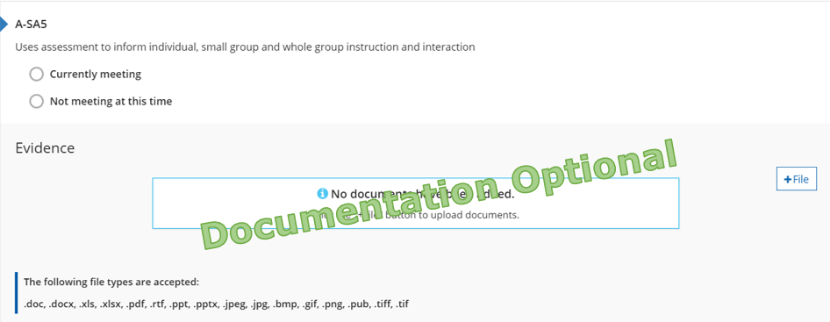
Figure 25. A-SA5 Indicator

Why this Indicator is Important
Documenting a child’s developmental progress over time allows staff to plan activities for the children’s daily experiences and to support ongoing development and learning based on data for each individual child, groups of children, and the program as a whole.

How a Program May Meet the Intent of the Indicator
☐ Provides evidence on how staff plan for the children based on assessment results.
☐ Provides family or program handbook(s) with policy on individual child planning.
☐ Share how staff use assessment results to set individual learning plans with families.
☐ Offers trainings or family nights regarding how to understand and use child assessment results to support learning and development.
☐ Other:
A Great Start to Quality Approved Assessment tool must be implemented twice per year to receive credit for this indicator.

Meeting the Indicator
The program has evidence of how the program use assessment results and notes to plan for all children.
Michigan’s Early Childhood Standards of Quality
Families have multiple opportunities for regular involvement with the program and its staff including placement, planning for individualization and evaluation related specifically to their child.

Reflection
☐ Currently Meeting
Document Name and Location:
Future Improvements:
☐ Not Currently Meeting
Goal for the future:
What do I want to learn?
Plan for implementation:

Points Possible for Screening and Assessment (0, 2, 4, or 6 pts.)
- Program has 0-1 of the indicators in place (0 pts.)
- Program has 2-3 of the indicators in place (2 pts.)
- Program has 4 of the indicators in place (4 pts.)
- Program has all 5 of the indicators in place (6 pts.)
Total points for Screening and Assessment Section:

A-AM1: Program has a basic contract for services rendered, which may include: Description of payment schedule, provider and child vacation policy, sick leave for child, alternative care options, and the termination policy
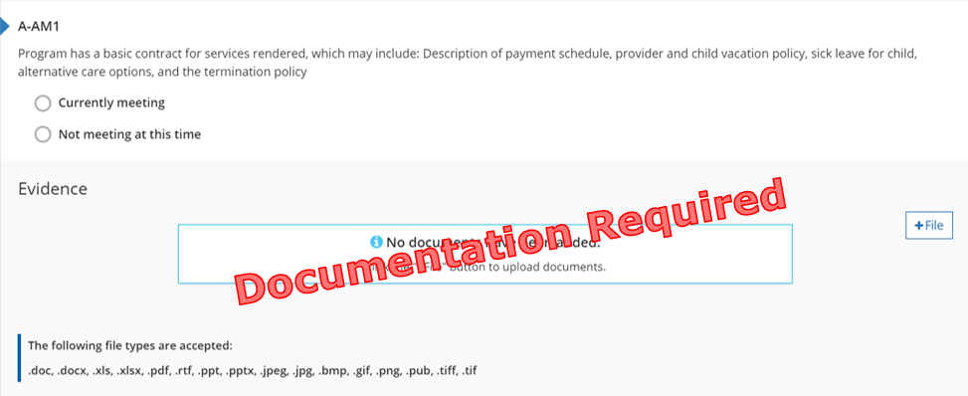
Figure 26. A-AM1 Indicator

Why this Indicator is Important
A written contract helps to set families up for success in understanding the expectations of the program and where to find answers about programming.

How a Program May Meet the Intent of the Indicator
☐ Provides family contract.
☐ Shares signature page from contract.
☐ Other:

Meeting the Indicator
The program has evidence showing a contract that is a formal agreement signed by both the families and the program for services provided for a specific child or children.
Michigan’s Early Childhood Standards of Quality
The facility is safe and secure and complies with the legal requirements of the local, state, and/or federal licensing or accrediting agency having jurisdiction over the program.

Reflection
☐ Currently Meeting
Document Name and Location:
Future Improvements:
☐ Not Currently Meeting
Goal for the future:
What do I want to learn?
Plan for implementation:

Points Possible for Administration and Management (0, 2, 4, or 6 pts.)
- Program has evidence of a written contract in place (2 pts.)

A-AM2: Written personnel policies and procedures
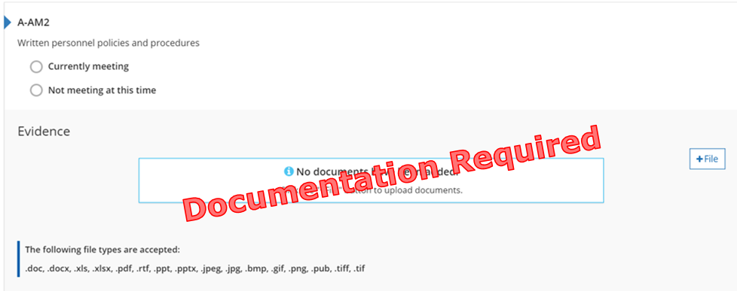
Figure 27. A-AM2 Indicator

Why this Indicator is Important
Clearly written policies and procedures set all staff members up for success. Written procedures ensure staff understand the expectations of the job or where to find answers about the expectations.

How a Program May Meet the Intent of the Indicator
☐ Provides staff handbook or its table of contents.
☐ Shares policy manual or its table of contents.
☐ Shares procedure manual or its table of contents.
☐ Provides job descriptions, guidelines, or protocols.
☐ Offers trainings on staff responsibilities and roles.
☐ Other:

Meeting the Indicator
The program has evidence showing the expectations of staff.
Michigan’s Early Childhood Standards of Quality
The program’s policies and practices support the enrollment and participation of all children including those with disabilities and promote an environment of acceptance that supports and respects gender, culture, language, ethnicity, individual capacities, and family composition.

Reflection
☐ Currently Meeting
Document Name and Location:
Future Improvements:
☐ Not Currently Meeting
Goal for the future:
What do I want to learn?
Plan for implementation:

Points Possible for Administration and Management (0, 2, 4, or 6 pts.)
- Program has evidence of a written personnel policies and procedures in place (2 pts.)

A-AM3A: Evidence of staff evaluations and individual professional development plans for each staff member
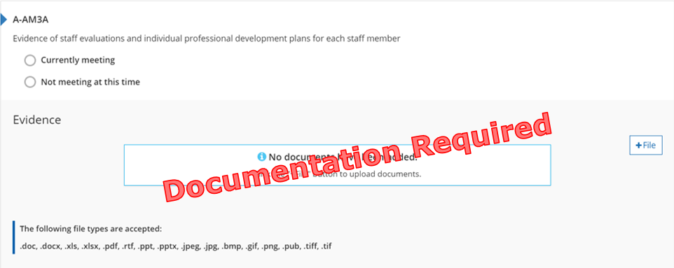
Figure 28. A-AM3A Indicator

Why this Indicator is Important
Reflecting on the growth of an educator over time allows for conversation between administration and staff to create professional development goals for development for the coming year.

How a Program May Meet the Intent of the Indicator
☐ Provides evidence of evaluations and individual professional development plans.
☐ Shares schedule for evaluations and individual professional development plans.
☐ Shares evaluation policies.
☐ Provides example of evaluations tool and professional development plans/goals.
☐ Shares information on how to set goals.
☐ Other:

Meeting the Indicator
The program has evidence showing staff are evaluated and have individual professional development plans.
Michigan’s Early Childhood Standards of Quality
Staff professional/career development efforts are assisted and supported by administrative policies, practices, and appropriate resources.

Reflection
☐ Currently Meeting
Document Name and Location:
Future Improvements:
☐ Not Currently Meeting
Goal for the future:
What do I want to learn?
Plan for implementation:

Points Possible for Administration and Management (0, 2, 4, or 6 pts.)
- Program has one of the following indicators in place (2 pts.)
  - A-AM3A
  - A-AM3B
  - A-AM3C
  - A-AM3D

A-AM3B: A documented, graduated salary scale for staff that takes into account education and experience
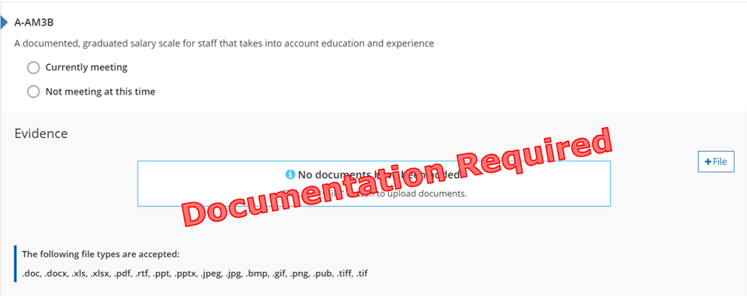
Figure 29. A-AM3B Indicator

Why this Indicator is Important
Offering a graduated salary scale encourages recruitment and retainment of qualified staff.

How a Program May Meet the Intent of the Indicator
☐ Provides written salary scale.
☐ Shares how salary scales takes into account both education and experience.
☐ Shares how the salary scale is used to determine a staff member’s wage/salary.
☐ Other:
The salary scale needs to be used at all times, not only when a staff member is being evaluated.
Salary scale must take into account both education and experience.

Meeting the Indicator
The program has evidence of a written salary scale.
Michigan’s Early Childhood Standards of Quality
Staff professional/career development efforts are assisted and supported by administrative policies, practices, and appropriate resources.

Reflection
☐ Currently Meeting
Document Name and Location:
Future Improvements:
☐ Not Currently Meeting
Goal for the future:
What do I want to learn?
Plan for implementation:

Points Possible for Administration and Management (0, 2, 4, or 6 pts.)
- Program has one of the following indicators in place (2 pts.)
  - A-AM3A
  - A-AM3B
  - A-AM3C
  - A-AM3D

A-AM3C: A flexible benefit plan that may include health, tuition assistance, etc. for staff
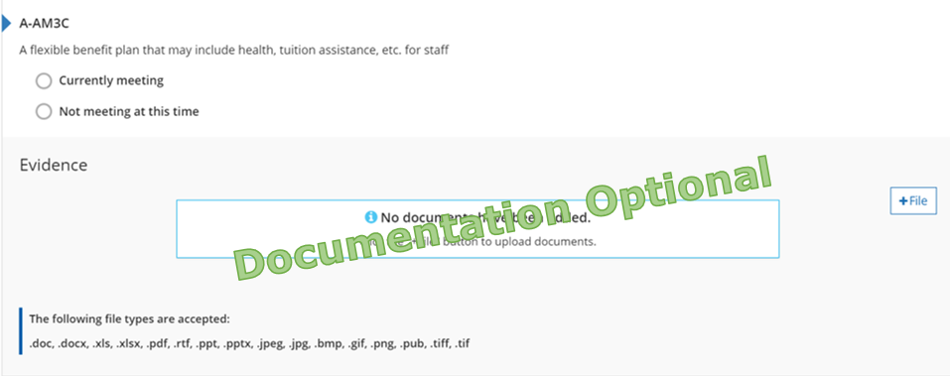
Figure 30. A-AM3C Indicator

Why this Indicator is Important
Flexible benefits encourage recruitment and retainment of qualified staff.

How a Program May Meet the Intent of the Indicator
☐ Provides benefits which may include:
- Health insurance
- Dental insurance
- Vision insurance
- Tuition assistance
- Child care discounts
- Payouts for not participating in insurance programs
- Paying for educator professional development or time for attending professional development
☐ Other:

Meeting the Indicator
Program has evidence full time staff are offered benefits.
Michigan’s Early Childhood Standards of Quality
Staff professional/career development efforts are assisted and supported by administrative policies, practices, and appropriate resources.

Reflection
☐ Currently Meeting
Document Name and Location:
Future Improvements:
☐ Not Currently Meeting
Goal for the future:
What do I want to learn?
Plan for implementation:

Points Possible for Administration and Management (0, 2, 4, or 6 pts.)
- Program has one of the following indicators in place (2 pts.)
  - A-AM3A
  - A-AM3B
  - A-AM3C
  - A-AM3D

A-AM3D: Paid leave time for full time employees which may include holiday, vacation, educational leave, and/or sick time
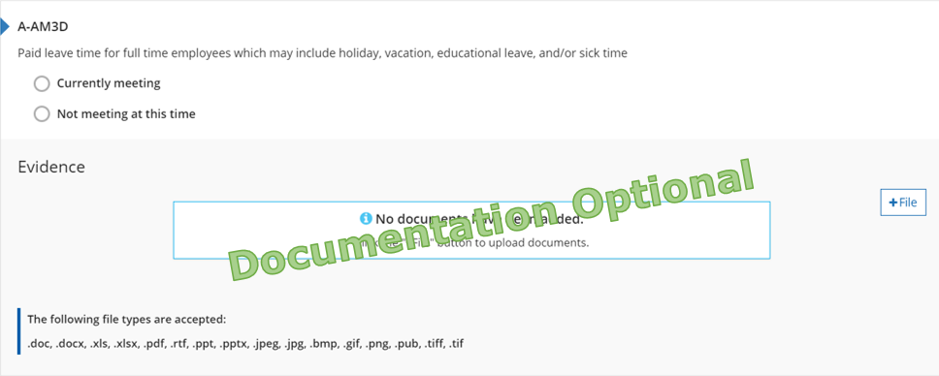
Figure 31. A-AM3D Indicator

Why this Indicator is Important
Paid leave time encourages recruitment and retainment of qualified staff.

How a Program May Meet the Intent of the Indicator
☐ Provides paid leave time which may include:
- Paid personal time
- Paid sick time
- Paid vacation time
- Paid holidays
- Paid snow days
☐ Other:

Meeting the Indicator
Program has evidence that full time staff are offered paid time off.
Michigan’s Early Childhood Standards of Quality
Staff professional/career development efforts are assisted and supported by administrative policies, practices, and appropriate resources.

Reflection
☐ Currently Meeting
Document Name and Location:
Future Improvements:
☐ Not Currently Meeting
Goal for the future:
What do I want to learn?
Plan for implementation:

Points Possible for Administration and Management (0, 2, 4, or 6 pts.)
- Program has one of the following indicators in place (2 pts.)
  - A-AM3A
  - A-AM3B
  - A-AM3C
  - A-AM3D
Total points for Administration and Management Section:

A-SQ1-A to D: Administrator/Director Qualifications
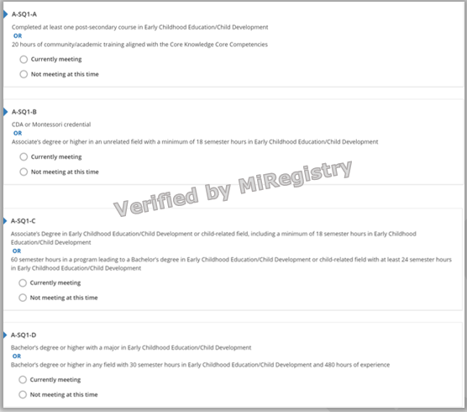
Figure 32. A-SQ1-A to D Indicators

Why this Indicator is Important
Obtaining specialized education and training allows Administrators/Directors to provide quality care, experiences, and environments that support every aspect of children’s growth and learning.

How a Program May Meet the Intent of the Indicator
The Administrator/Director is a member of MiRegistry, has their qualifications verified, and meets the intent of one of the Administrator/Director Qualifications indicators:
- Completed one college course in Early Childhood Education/Child Development.
- Completed 20 hours of training at any time in their life.
- A current CDA.
- A Montessori credential from the Association Montessori International (AMI), American Montessori Society (AMS), or Montessori Accreditation Council for Teacher Education (MACTE).
- An Associates degree (or higher) in an unrelated field and 18 semester hours in Early Childhood Education/Child Development.
- An Associates degree in Early Childhood Education/Child Development/child-related field and 18 semester hours in Early Childhood Education/Child Development.
- Working on a Bachelor’s degree in Early Childhood Education/Child Development/child-related field with 60 completed semester hours and 24 semesters hours in Early Childhood Education/Child Development.
- A Bachelor’s degree (or higher) with a major in Early Childhood Education/Child Development.
- A Bachelor’s degree (or higher) in any field, 30 semester hours in Early Childhood Education/Child Development, and 480 hours of experience.
Michigan’s Early Childhood Standards of Quality
The program administrator is, or the program employs an early childhood specialist who is qualified to administer or collaborate in the administration of the program, including supervision and management, program and staff evaluation, and program and staff development.

A-SQ1-A to D: Administrator/Director Qualifications

Staffing
Name of Administrator/Director:
☐ Administrator/Director is connected to the Organization Profile.
☐ Administrator/Director is connected to the Classrooms Tab of STARS.
☐ Qualifications sent to MiRegistry for verification.

Reflection
☐ Currently Meeting
Administrator/Director Qualifications Indicator currently meeting:
Future Improvements:
☐ Not Currently Meeting
Goal for the future:
What do I want to learn?
Plan for implementation:

Points Possible for Administrator/Director Qualifications (1 to 4 pts.)
Administrator meets A-SQ1-A (1 pt.)
- Completed at least one post-secondary course in Early Childhood Education/Child Development OR 20 hours of community/academic training aligned with the Core Knowledge Core Competencies.
Administrator meets A-SQ1-B (2 pts.)
- CDA or Montessori credential OR Associates degree or higher in an unrelated field with a minimum of 18 semester hours in Early Childhood Education/Child Development.
Administrator meets A-SQ1-C (3 pts.)
- Associates Degree in Early Childhood Education/Child Development or child-related field, including a minimum of 18 semester hours in Early Childhood Education/Child Development OR 60 semester hours in a program leading to a Bachelor’s degree in Early Childhood Education/Child Development or child-related field with at least 24 semester hours in Early Childhood Education/Child Development.
Administrator meets A-SQ1-D (4 pts.)
- Bachelor’s degree or higher with a major in Early Childhood Education/Child Development OR Bachelor’s degree or higher in any field with 30 semester hours in Early Childhood Education/Child Development and 480 hours of experience.
Total points for Administrator/Director Qualifications Section:

A-SQ2-A to D: Lead Provider/Educator/Teacher Qualifications
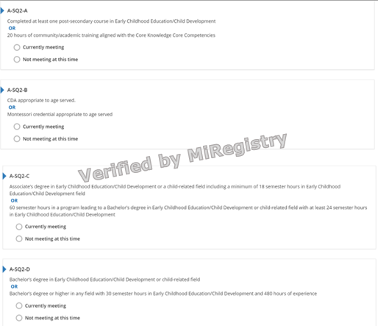
Figure 33. A-SQ2-A to D Indicators

Why this Indicator is Important
Obtaining specialized education and training allows staff to provide quality care, experiences, and environments that support every aspect of children’s growth and learning.

How a Program May Meet the Intent of the Indicator
The Lead Provider/Educator/Teacher is a member of MiRegistry, has their qualifications verified, and meets the intent of one of the Lead Provider/Educator/Teacher Qualifications indicators:
- Completed one college course in Early Childhood Education/Child Development.
- Completed 20 hours of training at any time in their life.
- A current CDA appropriate to aged served.
- A Montessori credential from the Association Montessori International (AMI), American Montessori Society (AMS), or Montessori Accreditation Council for Teacher Education (MACTE) appropriate to aged served.
- An Associates degree in Early Childhood Education/Child Development/child-related field and 18 semester hours in Early Childhood Education/Child Development.
- Working on a Bachelor’s degree in Early Childhood Education/Child Development/child-related field with 60 completed semester hours and 24 semesters hours in Early Childhood Education/Child Development.
- A Bachelor’s degree (or higher) with a major in Early Childhood Education/Child Development/child-related field.
- A Bachelor’s degree (or higher) in any field, 30 semester hours in Early Childhood Education/Child Development, and 480 hours of experience.
Michigan’s Early Childhood Standards of Quality
Teachers are qualified to develop and implement a program consistent with the program philosophy and appropriate to the developmental and learning needs of the children and families being served, including the development of a continuing parent education and family involvement component.

A-SQ2-A to D: Lead Provider/Educator/Teacher Qualifications

Staffing
Names of Lead Provider/Educator/Teacher(s):
☐ Lead Provider/Educator/Teacher(s) is connected to the Organization Profile.
☐ Lead Provider/Educator/Teacher(s) is connected to the correct classroom on STARS.
☐ Lead Provider/Educator/Teacher(s) has the correct title in the Employee Tab on STARS.
☐ Qualifications sent to MiRegistry for verification.

Reflection
☐ Currently Meeting
Lead Provider/Educator/Teacher Qualifications Indicator currently meeting:
Future Improvements:
☐ Not Currently Meeting
Goal for the future:
What do I want to learn?
Plan for implementation:

Points Possible for Lead Provider/Educator/Teacher Qualifications (1 to 4 pts.)
Lead Provider/Educator/Teacher meet A-SQ2-A (1 pt.)
- Completed at least one post-secondary course in Early Childhood Education/Child Development OR 20 hours of community/academic training aligned with the Core Knowledge Core Competencies.
Lead Provider/Educator/Teacher meet A-SQ2-B (2 pts.)
- CDA appropriate to age served OR Montessori credential appropriate to age served.
Lead Provider/Educator/Teacher meet A-SQ2-C (3 pts.)
- Associates degree in Early Childhood Education/Child Development or a child-related field including a minimum of 18 semester hours in Early Childhood Education/Child Development field OR 60 semester hours in a program leading to a Bachelor’s degree in Early Childhood Education/Child Development or child-related field with at least 24 semester hours in Early Childhood Education/Child Development.
Lead Provider/Educator/Teacher meet A-SQ2-D (4 pts.)
- Bachelor’s degree in Early Childhood Education/Child Development or child-related field OR Bachelor’s degree or higher in any field with 30 semester hours in Early Childhood Education/Child Development and 480 hours of experience.
Total points for Lead Provider/Educator/Teacher Qualifications Section:

A-SQ3-A to C: Assistant Provider/Educator/Teacher Qualifications
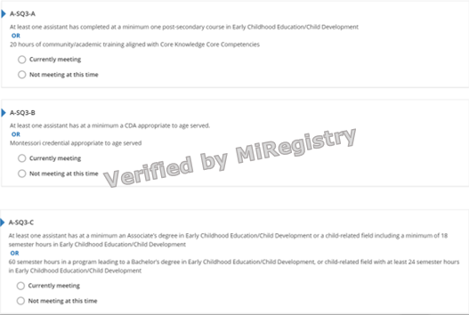
Figure 34. A-SQ3-A to C Indicators

Why this Indicator is Important
Obtaining specialized education and training allows staff to provide quality care, experiences, and environments that support every aspect of children’s growth and learning.

How a Program May Meet the Intent of the Indicator
At least one Assistant Provider/Educator/Teacher is a member of MiRegistry, has their qualifications verified, and meets the intent of one of the Assistant Provider/Educator/Teacher Qualifications indicators:
- Completed one college course in Early Childhood Education/Child Development.
- Completed 20 hours of training at any time in their life.
- A current CDA appropriate to aged served.
- A Montessori credential from the Association Montessori International (AMI), American Montessori Society (AMS), or Montessori Accreditation Council for Teacher Education (MACTE) appropriate to aged served.
- An Associates degree (or higher) in Early Childhood Education/Child Development/child-related field and 18 semester hours in Early Childhood Education/Child Development.
- Working on a Bachelor’s degree in Early Childhood Education/Child Development/child-related field with 60 completed semester hours and 24 semesters hours in Early Childhood Education/Child Development.
Michigan’s Early Childhood Standards of Quality
Paraprofessionals (i.e., those staff who work with children under the supervision of a teacher) are trained to implement program activities and assist in the care and education of the children.

A-SQ3-A to C: Assistant Provider/Educator/Teacher Qualifications

Staffing
Names of Assistant Provider/Educator/Teacher(s):
☐ Assistant Provider/Educator/Teacher(s) is connected to the Organization Profile.
☐ Assistant Provider/Educator/Teacher(s) is connected to the correct classroom on STARS.
☐ Assistant Provider/Educator/Teacher(s) has the correct title in the Employee Tab on STARS.
☐ Qualifications sent to MiRegistry for verification.

Reflection
☐ Currently Meeting
Assistant Provider/Educator/Teacher Qualifications Indicator currently meeting:
Future Improvements:
☐ Not Currently Meeting
Goal for the future:
What do I want to learn?
Plan for implementation:

Points Possible for Assistant Provider/Educator/Teacher Qualifications (1 to 3 pts.)
Assistant provider/Educator/Teacher meet A-SQ3-A (1 pt.)
- At least one assistant has completed at a minimum one post-secondary course in Early Childhood Education/Child Development or 20 hours of community/academic training aligned with Core Knowledge Core Competencies.
Assistant provider/Educator/Teacher meet A-SQ3-B (2 pts.)
- At least one assistant has at a minimum a CDA appropriate to age served OR Montessori credential appropriate to age served.
Assistant provider/Educator/Teacher meet A-SQ3-C (3 pts.)
- At least one assistant has at a minimum an Associates degree in Early Childhood Education/Child Development or a child-related field including a minimum of 18 semester hours in Early Childhood Education/Child Development OR 60 semester hours in a program leading to a Bachelor’s degree in Early Childhood Education/Child Development, or child-related field with at least 24 semester hours in Early Childhood Education/Child Development.
Total points for Assistant Provider/Educator/Teacher Qualifications Section:

A-PD1: Lead provider/educator completes at least 20 clock hours of professional development, and assistant(s) complete 10 hours of professional development annually
Figure 35. A-PD1 Indicator

Why this Indicator is Important
Continued professional development and training supports staff members’ knowledge on current best practices, providing quality care, experiences, and environments that support every aspect of children’s growth and learning.

How a Program Meets the Intent of the Indicator
The Lead provider/educator has:
- Completed 20 hours of professional development within the last 12 months from the month the Self-Assessment Survey was submitted.
- Professional development training verified by MiRegistry.
The assistant(s) has:
- Completed 10 hours of professional development within the last 12 months from the month the Self-Assessment Survey was submitted.
- Professional development training verified by MiRegistry.
Recently hired staff (hired for less than 90 days) do not require a certain number of professional development training hours.
CPR and First Aid hours do not count toward the total professional development hours.
Michigan’s Early Childhood Standards of Quality
The staff participates in a variety of ongoing professional development activities (e.g., in-service training, professional workshops, courses at institutions of higher learning, teacher exchanges, observations, coaching).

Reflection
☐ Currently Meeting
Document Name and Location:
Future Improvements:
☐ Not Currently Meeting
Goal for the future:
What do I want to learn?
Plan for implementation:

Points Possible for Professional Development (3 pts.)
- Program has evidence of annual professional development in place (2 pts.)

A-PD2: Professional development training attended by provider and any staff includes at least 2 hours focused on cultural competence OR inclusive practices, related to serving children with special needs or disabilities, as well as teaching diverse children and supporting diverse children and their families
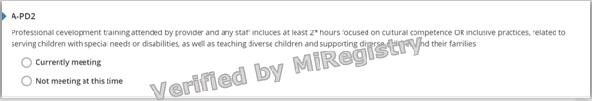
Figure 36. A-PD2 Indicator

Why this Indicator is Important
Ongoing professional development trainings support staff members’ knowledge on current best practices related to cultural competence or inclusive practices (e.g., culture, diversity, special needs, inclusion, etc.).

How a Program Meets the Intent of the Indicator
The provider and any staff have:
- Completed 2 hours of professional development focused on cultural competence/inclusive practices (e.g., serving children with special needs or disabilities, teaching diverse children, supporting diverse children and their families, etc.) within the last 12 months from the month the Self-Assessment Survey was submitted.
- Professional development training verified by MiRegistry.
Recently hired staff (hired for less than 90 days) do not require a certain number of professional development training hours.
Michigan’s Early Childhood Standards of Quality
The staff participates in a variety of ongoing professional development activities (e.g., in-service training, professional workshops, courses at institutions of higher learning, teacher exchanges, observations, coaching).

Reflection
☐ Currently Meeting
Document Name and Location:
Future Improvements:
☐ Not Currently Meeting
Goal for the future:
What do I want to learn?
Plan for implementation:

Points Possible for Professional Development (3 pts.)
- Program has evidence of professional development focused on cultural competence or inclusive practices in place (1 pt.)
Total points for Professional Development Section:

A-OS1: Lead provider/educator has a graduate degree in Early Childhood or Child Development or a related field OR Works at least monthly with an Early Childhood Specialist with a graduate degree in Early Childhood or Child Development or a related field
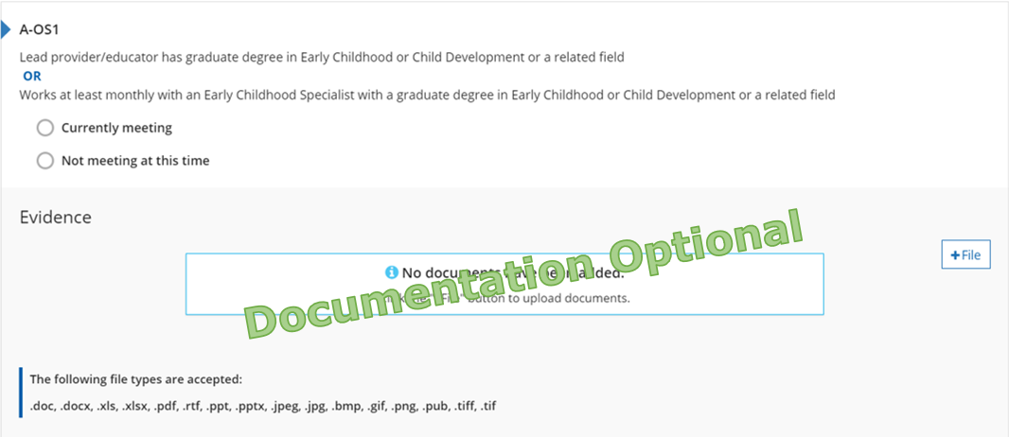
Figure 37. A-OS1 Indicator

Why this Indicator is Important
Ongoing individualized coaching and consultation supports the program to improve the quality of care through observations, action plans, meeting notes, emails, etc.

How a Program May Meet the Intent of the Indicator
- Administrator/Director has a Master’s degree (or higher) in Early Childhood Education, Child Development, or a child-related field.
- Evidence the Early Childhood Specialist has their Master’s degree (or higher) in Early Childhood Education, Child Development, or child-related field, and can provide evidence of monthly meetings for coaching and consultation.
- Evidence showing the program is currently working on a monthly basis with a Quality Improvement Consultant through their local Great Start to Quality Resource Center.

Meeting the Indicator
The program has evidence of consultation or coaching on a monthly basis.
Michigan’s Early Childhood Standards of Quality
The program administrator is or the program employs an early childhood specialist who is qualified to administer or collaborate in the administration of the program, including supervision and management, program and staff evaluation, and program and staff development.

Reflection
☐ Currently Meeting
Document Name and Location:
Future Improvements:
☐ Not Currently Meeting
Goal for the future:
What do I want to learn?
Plan for implementation:

Points Possible for Other Staffing (2 pts.)
- Program has evidence of monthly coaching or consultation in place (1 pt.)

A-OS2: Program develops Quality Improvement Plan designed to improve quality in staff qualifications and progress is monitored by a Quality Improvement Consultant
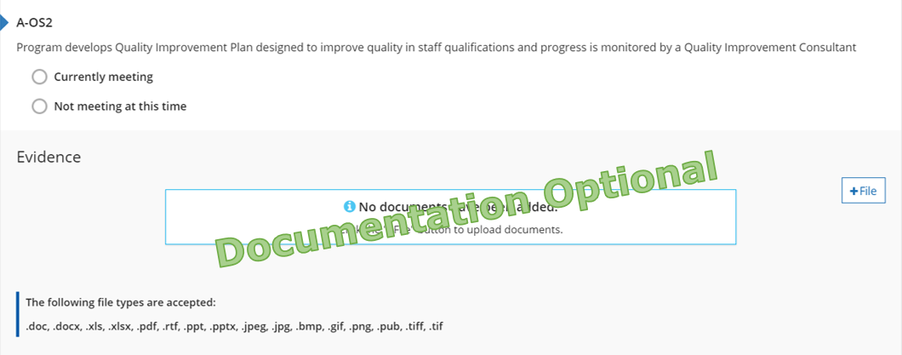
Figure 38. A-OS2 Indicator

Why this Indicator is Important
Monitoring a program’s written plan to encourage program quality and work on staff qualifications shows a dedication to improvement and high-quality programming.

How a Program May Meet the Intent of the Indicator
- A Quality Improvement Plan is a document that states the program’s goals for improving staff qualifications, the plan to reach those goals, and the steps that will be taken to achieve/complete the goals.
- Quality Improvement Plans from outside STARS will meet the intent of this indicator if the plan clearly explains how the program is working to improve staff qualifications.
- Professionals other than Quality Improvement Consultants may monitor the progress, if they have a Master’s degree (or higher) in Early Childhood Education, Child Development, or a child-related field.

Meeting the Indicator
The program has evidence of a Quality Improvement Plan designed to improve staff qualifications that is monitored by someone with a Master’s degree or a Quality Improvement Consultant.
Michigan’s Early Childhood Standards of Quality
The program implements program evaluation processes to learn how the program can be improved and be accountable.

Reflection
☐ Currently Meeting
Document Name and Location:
Future Improvements:
☐ Not Currently Meeting
Goal for the future:
What do I want to learn?
Plan for implementation:

Points Possible for Other Staffing (2 pts.)
- Program has evidence of a Quality Improvement Plan in place (1 pt.)
Total points for Other Staffing Section:

Calculating Potential Self-Assessment Survey Score

Total Section Score
Enter the total points for each section of the Self-Assessment Survey. Reference page for each section is in parenthesis. Add each total category score in the SAS Points column below. Add all category scores to determine total points. Remember to reference the minimum points and minimum categories to achieve each rating level.

Family and Community Partnership
Family Partnership (Page 18): ___
Community Partnership (Page 11): ___
Total Category Score: ___
Environment
Physical Environment (Page 12): ___
Ratios (Page 13): ___
Health Environment (Page 18): ___
Total Category Score: ___
Curriculum and Instruction
Curriculum and Instruction (Page 23): ___
Screening and Assessment (Page 28): ___
Total Category Score: ___
Administration and Management
Administration and Management (Page 34): ___
Total Category Score: ___
Staff Qualifications and Professional Development
Administrator/Director Qualifications (Page 36): ___
Lead Provider/Educator/Teacher Qualifications (Page 38): ___
Assistant Provider/Educator/Teacher Qualifications (Page 40): ___
Professional Development (Page 42): ___
Other Staffing (Page 44): ___
Total Category Score: ___

Category Possible Points SAS
Per Category Points 2 Star 3 Star 4 Star 5 Star
Family and Community Partnerships 8 ___ 4 4 6 6
Environment 8 ___ 2 4 6 6
Curriculum and Instruction 12 ___ 4 6 8 8
Administration and Management 6 ___ 2 4 4 4
Staff Qualifications and PD 16 ___ 3 6 8 8
Additional points in any other category ___ 1 2 6 10
Total 50 ___
Minimum points/minimum categories 16/2 26/3 38/4 42/5

