Great Start to Quality Program Quality Indicators Guidance for Child Care Centers 5-12
September 2021
Funding from the Office of Great Start within the Michigan Department of Education supports the implementation of Great Start.

Introduction
Great Start to Quality is Michigan’s quality rating and improvement system that supports programs, while also helping families find and choose quality programs that meet their schoolager’s needs. There are more than 40 different program quality indicators Great Start to Quality uses to measure the quality of programs. A program quality indicator is a standard used to measure the quality of a program in a specific area. Each program quality indicator falls into one of five categories. These five categories and indicators appear on the Self-Assessment Survey.
The categories on the Self-Assessment Survey are:
- Family and Community Partnerships
- Environment
- Curriculum and Instruction
- Administration and Management
- Staff Qualifications and Professional Development

How to Use the Guidance Document
This document is for planning and reflection purposes only and can help when completing the Self-Assessment Survey. The use of this document does not guarantee that credit will be given for each indicator selected. This document can help organize which documents should be uploaded as evidence or help plan for the rating process. This document is intended to be a working document used throughout the rating process. The guidance document will:
- Help programs understand the indicators
- Help programs understand the intent (purpose/goal) and importance of each indicator
- Give explanations, ideas, and suggestions of what to upload to show the intent of the indicators are being met
Throughout the document a reflection section is provided. In this section, programs can:
- Select whether the program is currently meeting or not currenting meeting the indicator
- Track name and location of documentation, such as where it may be saved
- Make notes of items for improvement, learn more about, and plan for implementation
This document is for planning and reflection purposes only. The use of this document does not guarantee credit will be given for each indicator selected.

Scoring
Throughout the document, the points possible for each indicator on the Self-Assessment Survey are included. As programs use this document, they can track the points they could possibly earn by adding them up. After completing the rating process, the program’s Self-Assessment Survey rating will be calculated on a scale of 1 through 5 Stars.
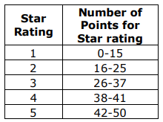
Figure 1- Points Distribution Chart
The chart shows the range of points needed for each star rating. Please note ratings are not calculated on points alone. For more details about the scoring of the Self-Assessment Survey, please see the Great Start to Quality Program Quality Indicators point distribution document or contact your local Great Start to Quality Resource Center at 1-877-614-7328 for further guidance and support.

General Information
Program Name: Enter Program Name
License Number: Enter License Number
MiRegistry Organization ID Number: Enter MiRegistry Organization ID Number

MiRegistry Login Information
Email Address: Enter Email Address for MiRegistry Login
Password: Enter MiRegistry Password

Great Start to Quality Login Information
Email Address: Enter Email Address for Great Start to Quality Login
Password: Enter Great Start to Quality Password

Star Rating Information
Current Star Rating: Select a Star Rating
Expiration Date: Select Expiration Date
Desired Star Rating: Select a Star Rating
Total Self-Assessment Survey Score: Enter Total Self-Assessment Survey Score

Support and Resources
Quality Improvement Specialist: Enter Quality Improvement Specialist’s Name
Contact Information: Enter Quality Improvement Specialist’s Contact Information
Quality Improvement Consultant: Enter Quality Improvement Consultant’s Name
Contact Information: Enter Quality Improvement Consultant’s Contact Information

Employment- MiRegistry Tracking
Date: Enter Current Date
This section can be used to assure staff have all information in MiRegistry and that it has been Verified. MiRegistry Membership Toolkit contains helpful information on how MiRegistry verifies qualifications and professional development.
Name | Position | Employment Verified on Organization Profile (Y/N) | Qualifications verified by MiRegistry (Y/N) | Professional Development Verified by MiRegistry (Y/N)

O-FC1: Program offers family education opportunities for all families
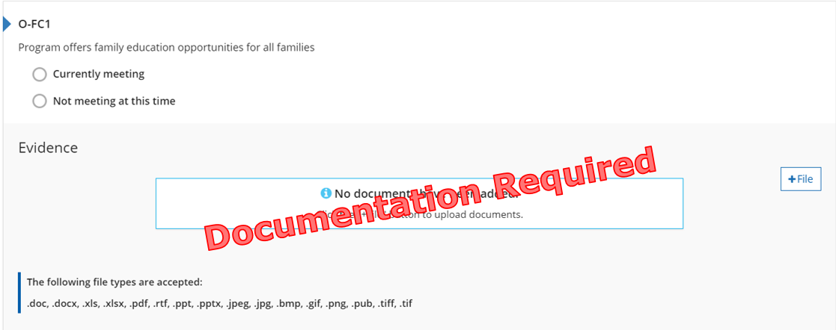
Figure 2. O-FC1 Indicator

Why this Indicator is Important
Families are the schoolager’s first teacher, through providing education materials and opportunities families will develop a deeper understanding of the schoolager’s development and educational experience.

How a Program May Meet the Intent of the Indicator
☐ Shares learning and training opportunities from program partners.
☐ Shares calendar of events and activities.
☐ Offers resources on the program’s website.
☐ Offers professional development opportunities for families.
☐ Other: Enter other ways the program meets the O-FC1 Indicator

Topics may include, but are not limited to:
- Family advocacy
- How to handle bullying
- Online safety and navigating social media
- Importance of school attendance

Meeting the Indicator
The program has evidence showing how families are provided with opportunities to engage in family education, enrichment, family support, child development, and other programs or groups.
Michigan’s Out-of-School Time Standards of Quality
II. Human Relationships C. The program creates a
positive social environment where all students feel safe.

Reflection
☐ Currently Meeting
Document Name and Location: Enter Document Name and Location for O-FC1 Indicator
Future Improvements: Enter Future Improvements for O-FC1 Indicator
☐ Not Currently Meeting
Goal for the future: Enter Future Goal for O-FC1 Indicator
What do I want to learn? Enter Desired Learning for O-FC1 Indicator
Plan for implementation: Enter Implementation Plan for O-FC1 Indicator

Points Possible for Family and Community Partnerships (8pts.)
- Program has family education opportunities in place (1 pt.)

O-FC2: Program staff engages in informal communication with families
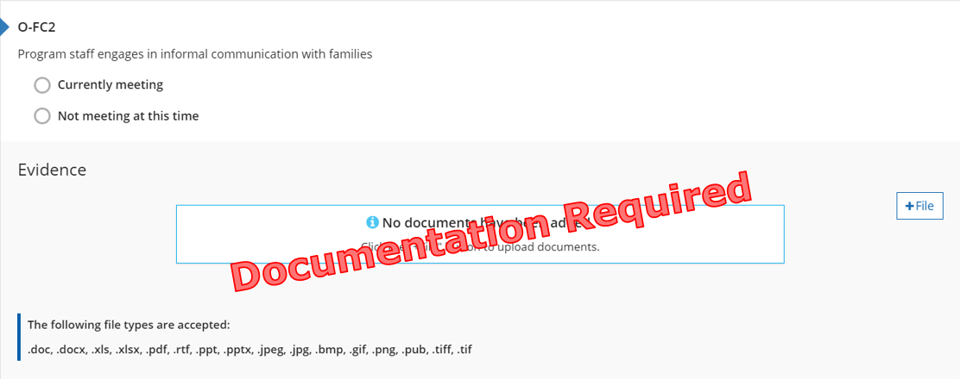
Figure 3. O-FC2 Indicator

Why this Indicator is Important
When staff interact informally with families, they support the development of an on-going relationship. Through sharing information about the schoolager’s development and involvement in the program it keeps families involved in their schoolager’s education.

How a Program May Meet the Intent of the Indicator
☐ Provides information about the schoolager’s day to families.
☐ Shares options for communication between administrators, educators, and families.
☐ Provides information about upcoming events through newsletters and handouts.
☐ Shares calendar of events and activities.
☐ Provides family or program handbook(s) including statement regarding informal communication.
☐ Other: Enter other ways the program meets the O-FC2 Indicator

Meeting the Indicator
The program has evidence of how the staff communicate with families about their schoolager’s day and development and how their schoolager is involved in the program.
Michigan’s Out-of-School Time Standards of Quality
V. Program and Activities D. Families are appropriately involved in decision making, planning, management, evaluation, implementation and improvement of the program.

Reflection
☐ Currently Meeting
Document Name and Location: Enter Document Name and Location for O-FC2 Indicator
Future Improvements: Enter Future Improvements for O-FC2 Indicator
☐ Not Currently Meeting
Goal for the future: Enter Future Goal for O-FC2 Indicator
What do I want to learn? Enter Desired Learning for O-FC2 Indicator
Plan for implementation: Enter Implementation Plan for O-FC2 Indicator

Points Possible for Family and Community Partnerships (8pts.)
- Program has informal communication in place (1 pt.)

O-FC3: Program has partnerships that take basic steps to facilitate schoolagers’ transitions before and after school, and between and among programs, agencies, and schools
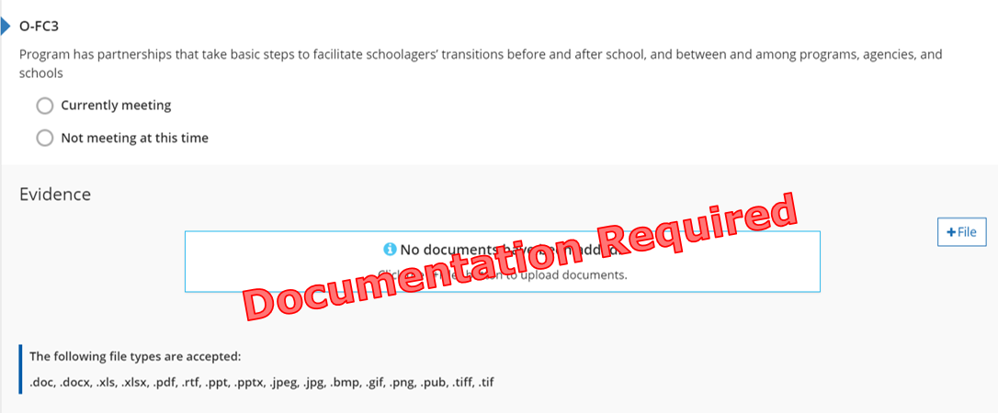
Figure 4. O-FC3 Indicator

Why this Indicator is Important
To provide quality continuity of care, program staff work cooperatively and collaboratively with community organizations, schools, and programs to ease schoolagers’ transitions. Partnerships and communication between all agencies allow for the social/emotional development of schoolager’s served.

How a Program May Meet the Intent of the Indicator
☐ Statement about transitions to summer programs.
☐ Shares transitions plans.
☐ Provides family or program handbook(s) including a policy on transitions.
☐ Examples of communication outreach to other partners.
☐ Intake forms or process communication logs.
☐ Exit survey (from families leaving the program).
☐ Other: Enter other ways the program meets the O-FC3 Indicator

Meeting the Indicator
The program has evidence of how the program helps facilitate transitions for all schoolagers.
Michigan’s Out-of-School Time Standards of Quality
V. Program and Activities F. Program collaborates with other
children and youth organizations, community resource agencies and schools to meet the needs of all participating youth.

Reflection
☐ Currently Meeting
Document Name and Location: Enter Document Name and Location for O-FC3 Indicator
Future Improvements: Enter Future Improvements for O-FC3 Indicator
☐ Not Currently Meeting
Goal for the future: Enter Future Goal for O-FC3 Indicator
What do I want to learn? Enter Desired Learning for O-FC3 Indicator
Plan for implementation: Enter Implementation Plan for O-FC3 Indicator

Points Possible for Family and Community Partnerships (8pts.)
- Program has evidence of transitions in place (1 pt.)

O-FC4: Program delivers communication, education, informational materials, and opportunities for families in way that meets diverse needs (e.g. literacy level, language, delivery method, cultural appropriateness)
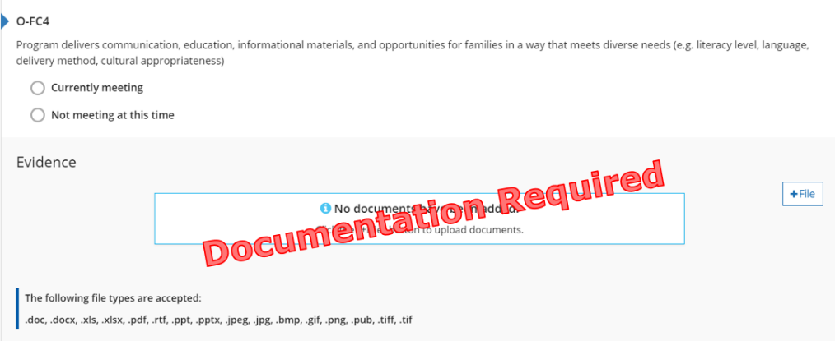
Figure 5. O-FC4 Indicator

Why this Indicator is Important
By providing families with information and/or resources in ways that meet their individual needs; staff ensure all families are included in programming.

How a Program May Meet the Intent of the Indicator
☐ Provides information in multiple languages.
☐ Shares resources for translation.
☐ Collects family survey or enrollment materials that include options for communication preferences.
☐ Provides family or program handbook(s) with a policy on different family structures and various modes of communication.
☐ Shares statement or policy on communicating with various family members or guardians.
☐ Other: Enter other ways the program meets the O-FC4 Indicator

Meeting the Indicator
The program has evidence showing how staff communicate with families in a way that meets their individual needs/preferences.
Michigan’s Out-of-School Time Standards of Quality
II. Human Relationships C. The program creates a
positive social environment where all students feel safe.

Reflection
☐ Currently Meeting
Document Name and Location: Enter Document Name and Location for O-FC4 Indicator
Future Improvements: Enter Future Improvements for O-FC4 Indicator
☐ Not Currently Meeting
Goal for the future: Enter Future Goal for O-FC4 Indicator
What do I want to learn? Enter Desired Learning for O-FC4 Indicator
Plan for implementation: Enter Implementation Plan for O-FC4 Indicator

Points Possible for Family and Community Partnerships (8pts.)
- Program has evidence of a communication policy in place (1 pt.)

O-FC5: Families and schoolagers have input into the design of the program
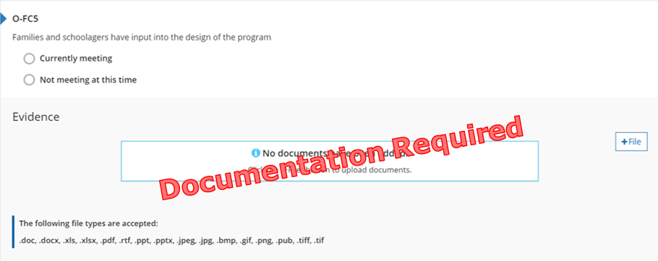
Figure 6. O-FC5 Indicator

Why this Indicator is Important
Providing families and schoolagers with options to make decisions will ensure the program meets the individual needs and interests of all schoolagers and families.

How a Program May Meet the Intent of the Indicator
☐ Provides opportunities for schoolagers and family members to sit on family advisory committee relating to the preschool or organization.
☐ Facilitates family and schoolager surveys throughout the year to collect input regarding the program.
☐ Provides various ways for families to be involved in making decisions that affect programming.
☐ Other: Enter other ways the program meets the O-FC5 Indicator

Meeting the Indicator
The program has program evidence showing how both schoolagers and families have the opportunity for input into the design of the program.
Michigan’s Out-of-School Time Standards of Quality
V. Program and Activities D. Families are appropriately involved in decision making, planning, management, evaluation, implementation and improvement of the program.

Reflection
☐ Currently Meeting
Document Name and Location: Enter Document Name and Location for O-FC5 Indicator
Future Improvements: Enter Future Improvements for O-FC5 Indicator
☐ Not Currently Meeting
Goal for the future: Enter Future Goal for O-FC5 Indicator
What do I want to learn? Enter Desired Learning for O-FC5 Indicator
Plan for implementation: Enter Implementation Plan for O-FC5 Indicator

Points Possible for Family and Community Partnerships (8pts.)
- Program has evidence of family and schoolager input in place (2 pts.)

O-FC6: Program has policy to provide or connect families to appropriate comprehensive services
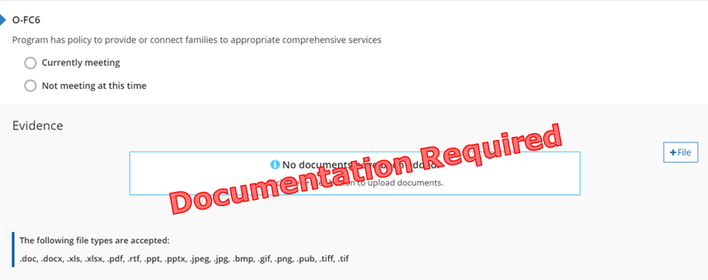
Figure 7. O-FC6 Indicator

Why this Indicator is Important
Connecting schoolagers and families with public/private community agencies supports the needs of, and awareness of, available resources. Ensuring families and schoolagers have their basic needs met allows for optimal development and growth.

How a Program May Meet the Intent of the Indicator
☐ Provides a list of community service contacts.
☐ Shares resource guides.
☐ Shares written report of on-site referrals.
☐ Provides family or program handbook(s) with information on comprehensive services.
☐ Shares handouts and contact information for local resources.
☐ Other: Enter other ways the program meets the O-FC6 Indicator

Meeting the Indicator
The program has a policy of how the staff help refer families to and access services through outside agencies/organizations.
Michigan’s Out-of-School Time Standards of Quality
V. Program and Activities F. Program collaborates with other
children and youth organizations, community resource agencies and schools to meet the needs of all participating youth.

Reflection
☐ Currently Meeting
Document Name and Location: Enter Document Name and Location for O-FC6 Indicator
Future Improvements: Enter Future Improvements for O-FC6 Indicator
☐ Not Currently Meeting
Goal for the future: Enter Future Goal for O-FC6 Indicator
What do I want to learn? Enter Desired Learning for O-FC6 Indicator
Plan for implementation: Enter Implementation Plan for O-FC6 Indicator

Points Possible for Family and Community Partnerships (8pts.)
- Program has a policy for comprehensive services in place (1 pt.)

O-FC7: Program has evidence it is involved in community organizations, partnerships, or collaborations that enhances its services to families, business practices, and/or child development knowledge
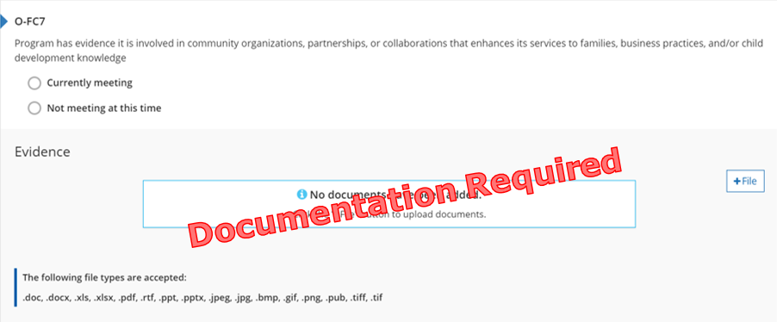
Figure 8. O-FC7 Indicator

Why this Indicator is Important
Partnering with other professional educational organizations allows programs to enhance its services to schoolagers and families through evidence-based research and business consultation.

How a Program May Meet the Intent of the Indicator
☐ Provides meeting agenda, meeting minutes, or membership from local or professional organization.
☐ Obtains local or national professional membership.
☐ Provides letters of partnerships or partnership agreements.
☐ Provides proof that 50% of staff members are members of MiRegistry.
☐ Other: Enter other ways the program meets the O-FC7 Indicator

Meeting the Indicator
The program has evidence it currently works with other professional organizations or agencies to enhance business practices, program practices, and improve services to families and schoolagers.
Michigan’s Out-of-School Time Standards of Quality
V. Program and Activities F. Program collaborates with other
children and youth organizations, community resource agencies and schools to meet the needs of all participating youth.

Reflection
☐ Currently Meeting
Document Name and Location: Enter Document Name and Location for O-FC7 Indicator
Future Improvements: Enter Future Improvements for O-FC7 Indicator
☐ Not Currently Meeting
Goal for the future: Enter Future Goal for O-FC7 Indicator
What do I want to learn? Enter Desired Learning for O-FC7 Indicator
Plan for implementation: Enter Implementation Plan for O-FC67 Indicator

Points Possible for Family and Community Partnerships (8pts.)
- Program has evidence of partnerships with community organization in place (1 pt.)
Total points in Family and Community Partnership Section: Choose total points in Family and Community Partnership Section

O-R1: Center demonstrates that it has smaller group size and better teacher: child ratio than required by licensing
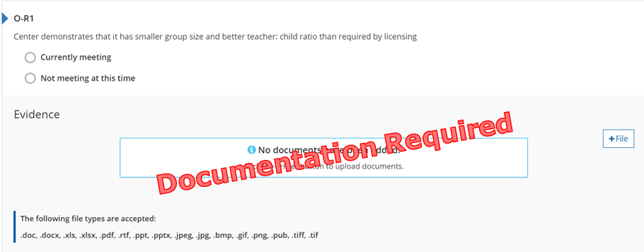
Figure 9. O-R1 Indicator

Why this Indicator is Important
Having more staff and fewer schoolagers than required by licensing creates a higher quality learning environment for schoolagers. This ensures staff have more one-on-one time with each schoolager.

How a Program May Meet the Intent of the Indicator
☐ Provides evidence of lower staff to schoolager ratios than required by licensing.
☐ Shares information with families about the importance of low ratios.
☐ Provides enrollment information including number of schoolagers and staff.
☐ Shares family or program handbook(s) with policy on classroom ratios.
☐ Other: Enter other ways the program meets the O-R1 Indicator

Meeting the Indicator
The program has evidence showing all classrooms always maintain better ratios than required by licensing.
Michigan’s Out-of-School Time Standards of Quality
III. Program Staffing A. Staff to student ratios and group size are established to ensure that authentic, helpful, and
caring relationships can be established and maintained
between children and youth in the program and the staff.

Reflection
☐ Currently Meeting
Document Name and Location: Enter Document Name and Location for O-R1 Indicator
Future Improvements: Enter Future Improvements for O-R1 Indicator
☐ Not Currently Meeting
Goal for the future: Enter Future Goal for O-R1 Indicator
What do I want to learn? Enter Desired Learning for O-R1 Indicator
Plan for implementation: Enter Implementation Plan for O-R1 Indicator

Points Possible for Ratios (0 or 2 pts.)
- Program has evidence of ratios in place (2 pts.)
Total points for Ratios Section: Choose total points for Ratios Section

O-HE2: Program dedicates 20 percent of daily program time to outdoor recreation, sports, or fitness activities, with appropriate indoor physical activities available when weather or other factors prohibit play
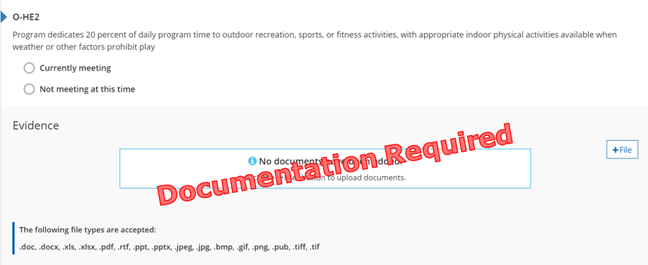
Figure 10. O-HE2 Indicator

Why this Indicator is Important
The outdoor natural learning environment is an extension of the classroom. It ensures schoolagers have access to seek out exercise, fresh air, and offers opportunities to learn and care for their local community and environment.

Formula
Total program time (in minutes) multiplied by 0.20 = 20% of daily program time

How a Program May Meet the Intent of the Indicator
☐ Provides a daily schedule that includes outdoor time.
☐ Shares options to active play when weather permits outdoor time.
☐ Shares information about the benefits of active plan and outdoor time.
☐ Provides family or program handbook(s) with information about outdoor play space and times.
☐ Other: Enter other ways the program meets the O-HE2 Indicator

Meeting the Indicator
The program has evidence showing every schoolager has 20% of the day scheduled for outdoor time.
Michigan’s Out-of-School Time Standards of Quality
IV. Indoor and Outdoor Environment B. The outdoor environment is established to offer a safe and age/ability appropriate area for daily outdoor play and sports.

Reflection
☐ Currently Meeting
Document Name and Location: Enter Document Name and Location for O-HE2 Indicator
Future Improvements: Enter Future Improvements for O-HE2 Indicator
☐ Not Currently Meeting
Goal for the future: Enter Future Goal for O-HE2 Indicator
What do I want to learn? Enter Desired Learning for O-HE2 Indicator
Plan for implementation: Enter Implementation Plan for O-HE2 Indicator

Points Possible for Health Environment (6 pts.)
- Program has evidence of outdoor time in place (2 pts.)

O-HE3: Program establishes and implements a written policy to address daily mental health and well-being
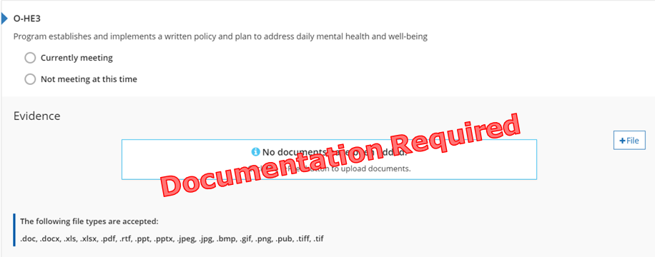
Figure 11. O-HE3 Indicator

Why this Indicator is Important
Program staff observe schoolagers’ mental health and well-being and communicate consistently with families about behavior changes, social/emotional well-being, and bullying during the school year. This ensures collaboration among families, schoolagers, and staff to address mental health at an early age.

How a Program May Meet the Intent of the Indicator
A written mental health policy must address when and how the program communicates observations to the schoolagers’ family, teachers, other educators, specialized staff, or recommendations for family to seek referrals.
☐ Provides family or program policy for addressing physical and/or mental health concerns.
☐ Shares information about mental health supports.
☐ Provides staff handbook with information about mental health and responding to emergencies.
☐ Other: Enter other ways the program meets the O-HE3 Indicator

Meeting the Indicator
The program has evidence showing how staff collects and shares information about schoolagers’ mental health, observations, and concerns with families.
Michigan’s Out-of-School Time Standards of Quality
II. Human Relationships B. All relationships engage children and youth in positive and respectful ways.

Reflection
☐ Currently Meeting
Document Name and Location: Enter Document Name and Location for O-HE3 Indicator
Future Improvements: Enter Future Improvements for O-HE3 Indicator
☐ Not Currently Meeting
Goal for the future: Enter Future Goal for O-HE3 Indicator
What do I want to learn? Enter Desired Learning for O-HE3 Indicator
Plan for implementation: Enter Implementation Plan for O-HE3 Indicator

Points Possible for Health Environment (6 pts.)
- Program has evidence of a mental health policy in place (2 pts.)

O-HE1: Nutrition Information
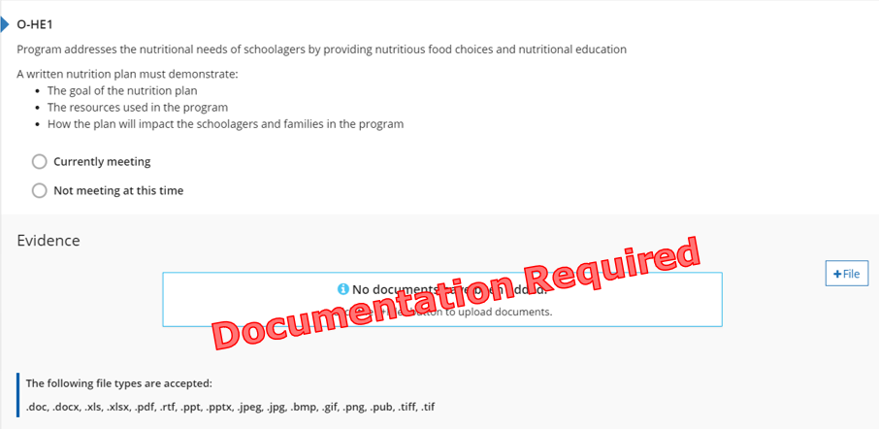
Figure 12. O-HE1 Indicator

Why this Indicator is Important
Nutrition is an important part of leading a healthy lifestyle. Understanding how nutrition supports the physical and mental well-being of schoolagers ensures they are prepared to actively learn and engage in school.

How a Program May Meet the Intent of the Indicator
A written nutrition plan must include:
- What is the goal of the plan.
- What tools and/or resources are being used to meet the goal.
- How do you use the tools or resources to assist in meeting the goal.
- Who you refer to for specialized information or services.
- Why the plan is important for the children, families, and staff in your programs.
- How it will help you meet the needs of children and families you serve and/or in your community.
Nutrition plans may also include:
- How schoolagers learn and socialize during meals.
- The types of foods you are serving.
- How you change menus for food allergies or dietary needs.
- Other: Enter other ways the program meets the O-HE1 Indicator

Meeting the Indicator
Program provides food- has a written nutrition plan AND participates with CACFP or follows CACFP menu guidelines
Program ONLY provides snack- has a written nutrition plan AND follows CACFP menu guidelines
Program does NOT provide food- provides nutrition information (recommendations or guidance on food schoolagers bring to the program) to families and schoolagers
Michigan’s Out-of-School Time Standards of Quality
I. Health and Safety G. The program serves food and drinks that meet the needs of all children and youth.

Reflection
☐ Currently Meeting
Document Name and Location: Enter Document Name and Location for O-HE1 Indicator
Future Improvements: Enter Future Improvements for O-HE1 Indicator
☐ Not Currently Meeting
Goal for the future: Enter Future Goal for O-HE1 Indicator
What do I want to learn? Enter Desired Learning for O-HE1 Indicator
Plan for implementation: Enter Implementation Plan for O-HE1 Indicator

Points Possible for Health Environment (6 pts.)
- Program has evidence of a nutrition plan in place (2 pts.)
Total points for Health Environment Section: Choose total points for Health Environment Section
O-CI1: Program has a written statement (mission or vision statement) of educational and developmental priorities for all schoolagers available to families
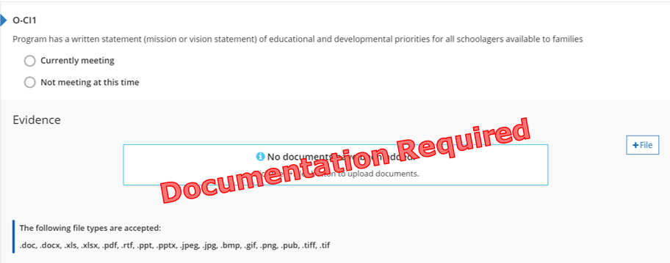
Figure 13. O-CI1 Indicator

Why this Indicator is Important
The program’s mission/vision statement informs families and schoolagers about their beliefs about how they serve the schoolagers and families involved in the program.

How a Program May Meet the Intent of the Indicator
☐ Shares written mission or vision statement.
☐ Provides family or program handbook(s) with mission or vision statement.
☐ Program has written goals for the children.
☐ Other: Enter other ways the program meets the O-CI1 Indicator

Meeting the Indicator
The program has evidence showing the intentional thinking and planning involved within the program.
Michigan’s Out-of-School Time Standards of Quality
V. Program Activities A. Activities are planned and supported through resources which reflect the interests and abilities of the children and youth enrolled and provide support for the school-day activities, especially supplementing the areas of development not regularly provided during the school day.

Reflection
☐ Currently Meeting
Document Name and Location: Enter Document Name and Location for O-CI1 Indicator
Future Improvements: Enter Future Improvements for O-CI1 Indicator
☐ Not Currently Meeting
Goal for the future: Enter Future Goal for O-CI1 Indicator
What do I want to learn? Enter Desired Learning for O-CI1 Indicator
Plan for implementation: Enter Implementation Plan for O-CI1 Indicator

Points Possible for Curriculum and Instruction (12 pts.)
- Program has evidence of a mission/vision statement in place (2 pts.)

O-CI2: Program has a plan in place to ensure there is youth voice and engagement, including leadership opportunities for schoolagers during the program
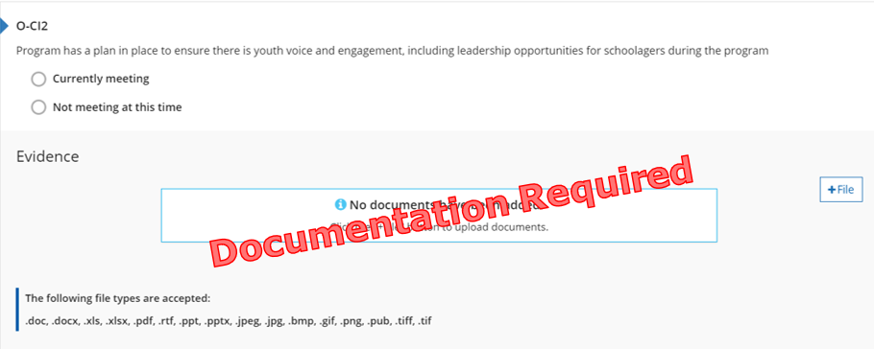
Figure 14. O-CI2 Indicator

Why this Indicator is Important
Providing schoolagers opportunities to express their opinions, beliefs, and expectations ensures a sense of belonging, engagement in their education, and empowers them to feel they are contributing members of their community.

How a Program May Meet the Intent of the Indicator
A written plan for schoolage voice and leadership must include:
- What is the goal of the plan.
- What tools and/or resources are being used to meet the goal.
- How do you use the tools or resources to assist in meeting the goal.
- Who you refer to for specialized information or services.
- Why the plan is important for the children, families, and staff in your programs.
- How it will help you meet the needs of children and families you serve and/or in your community.

Meeting the Indicator
Program provides schoolagers intentional opportunities to identify and lead activities and hands-on experiences with others to enhance their developmental outcomes.
Michigan’s Out-of-School Time Standards of Quality
V. Program Activities C. Program development and implementation is carried out in such a way to include significant child and youth choice and child and youth involvement in planning and leading.

Reflection
☐ Currently Meeting
Document Name and Location: Enter Document Name and Location for O-CI2 Indicator
Future Improvements: Enter Future Improvements for O-CI2 Indicator
☐ Not Currently Meeting
Goal for the future: Enter Future Goal for O-CI2 Indicator
What do I want to learn? Enter Desired Learning for O-CI2 Indicator
Plan for implementation: Enter Implementation Plan for O-CI2 Indicator

Points Possible for Curriculum and Instruction (12 pts.)
- Program has a plan for schoolager voice and leadership in place (2 pts.)

O-CI3: Program has a policy and plan in place to ensure that planned activities and academic experiences incorporate the diversity of the schoolagers and families within the program
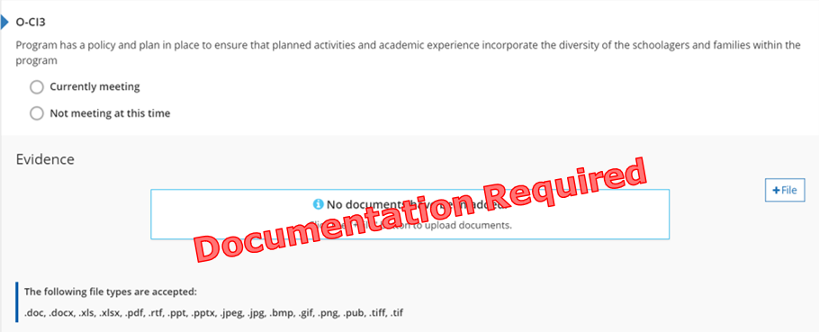
Figure 15. O-CI3 Indicator

Why this Indicator is Important
Program staff provide opportunities to identify and celebrate the diversity of schoolagers’ families and community and other cultures. This encourages increased self-esteem, pride in ones culture, feelings of acceptance of all cultures to become global citizens.

How a Program May Meet the Intent of the Indicator
A written plan for incorporating diversity into the program must include:
- What is the goal of the plan.
- What tools and/or resources are being used to meet the goal.
- How do you use the tools or resources to assist in meeting the goal.
- Who you refer to for specialized information or services.
- Why the plan is important for the children, families, and staff in your programs.
- How it will help you meet the needs of children and families you serve and/or in your community.

Meeting the Indicator
The program has a plan that ensures activities and experiences are diverse and represent the cultures, family structure, and traditions of the schoolagers and families in the program.
Michigan’s Out-of-School Time Standards of Quality
IV. Indoor and Outdoor Environment E. The environment reflects the diversity represented in the population of the community and gender equity.

Reflection
☐ Currently Meeting
Document Name and Location: Enter Document Name and Location for O-CI3 Indicator
Future Improvements: Enter Future Improvements for O-CI3 Indicator
☐ Not Currently Meeting
Goal for the future: Enter Future Goal for O-CI3 Indicator
What do I want to learn? Enter Desired Learning for O-CI3 Indicator
Plan for implementation: Enter Implementation Plan for O-CI3 Indicator

Points Possible for Curriculum and Instruction (12 pts.)
- Program has a plan for incorporating diversity into the program in place (2 pts.)

O-CI4: Program has a written plan for serving schoolagers with special needs
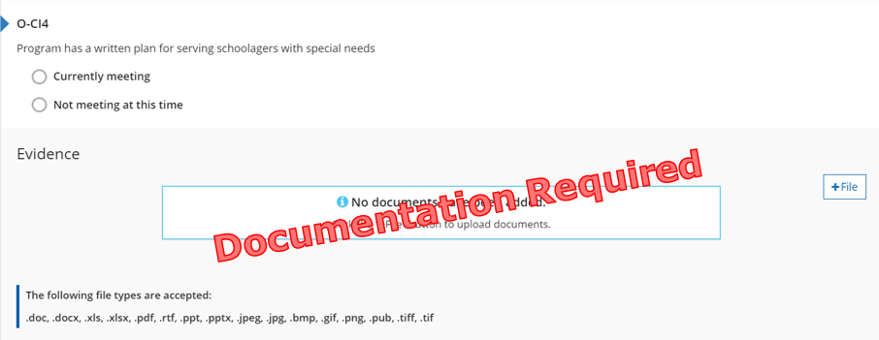
Figure 16. O-CI4 Indicator

Why this Indicator is Important
Program staff provide opportunities to identify, support and learn about the different learning styles and abilities of schoolagers’, family and community members. This encourages increased self-esteem, understanding of differences, feelings of acceptance of all abilities to become global citizens.

How a Program May Meet the Intent of the Indicator
A written plan for serving schoolagers with special needs must include:
- What is the goal of the plan.
- What tools and/or resources are being used to meet the goal.
- How do you use the tools or resources to assist in meeting the goal.
- Who you refer to for specialized information or services.
- Why the plan is important for the children, families, and staff in your programs.
- How it will help you meet the needs of children and families you serve and/or in your community.

Meeting the Indicator
The program has evidence of a written special needs plan.
Michigan’s Out-of-School Time Standards of Quality
IV. Indoor and Outdoor Environment F. The environment reflects various learning styles and abilities of all children and youth.

Reflection
☐ Currently Meeting
Document Name and Location: Enter Document Name and Location for O-CI4 Indicator
Future Improvements: Enter Future Improvements for O-CI4 Indicator
☐ Not Currently Meeting
Goal for the future: Enter Future Goal for O-CI4 Indicator
What do I want to learn? Enter Desired Learning for O-CI4 Indicator
Plan for implementation: Enter Implementation Plan for O-CI4 Indicator

Points Possible for Curriculum and Instruction (12 pts.)
- Program has a plan for serving schoolagers with special needs in place (2 pts.)

O-CI5: Program has a written plan to ensure that planned activities and academic experience provide a variety of hands-on developmentally appropriate experiences
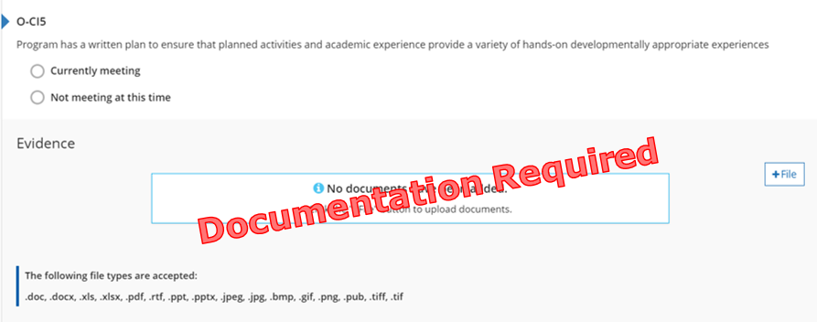
Figure 17. O-CI5 Indicator

Why this Indicator is Important
Providing opportunities to explore learning through multiple hands-on experiences ensures each schoolagers learning style is met.

How a Program May Meet the Intent of the Indicator
A written plan for academic activities must include:
- What is the goal of the plan.
- What tools and/or resources are being used to meet the goal.
- How do you use the tools or resources to assist in meeting the goal.
- Who you refer to for specialized information or services.
- Why the plan is important for the children, families, and staff in your programs.
- How it will help you meet the needs of children and families you serve and/or in your community.
Opportunities must include the following content areas:
- Social-emotional
- Physical
- Academic
- Creative Expression
- Culture
- Character development
- STEM- Science, Technology, Engineering, Mathematics

Meeting the Indicator
The program offers active learning opportunities and supports the State of Michigan Educational Technology Plan.
Michigan’s Out-of-School Time Standards of Quality
V. Program Activities A. Activities are planned and supported through resources which reflect the interests and abilities of the children and youth enrolled and provide support for the school-day activities, especially supplementing the areas of development not regularly provided during the school day.

Reflection
☐ Currently Meeting
Document Name and Location: Enter Document Name and Location for O-CI5 Indicator
Future Improvements: Enter Future Improvements for O-CI5 Indicator
☐ Not Currently Meeting
Goal for the future: Enter Future Goal for O-CI5 Indicator
What do I want to learn? Enter Desired Learning for O-CI5 Indicator
Plan for implementation: Enter Implementation Plan for O-CI5 Indicator

Points Possible for Curriculum and Instruction (12 pts.)
- Program has a plan for academic activities with special needs in place (4 pts.)
Total points for Curriculum and Instruction Section: Choose total points for Curriculum and Instruction Section

O-AM1: Program has written personnel policies and procedures (staff handbook) that includes, at a minimum, a written plan for: staff orientation, retention, evaluation, and individual professional development plans
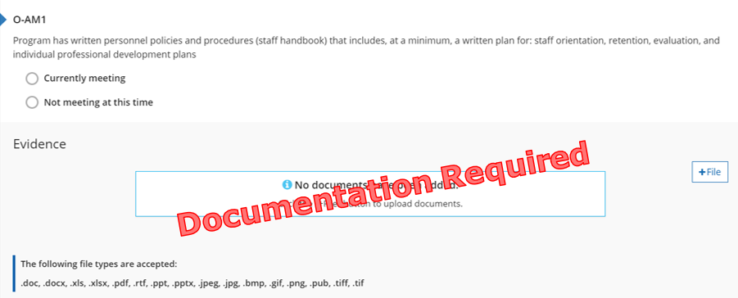
Figure 18. O-AM1 Indicator

Why this Indicator is Important
Clearly written policies and procedures sets all staff members up for success through ensuring staff understand the expectations of the job or where to find answers about the expectations.

How a Program May Meet the Intent of the Indicator
☐ Provides staff handbook or its table of contents.
☐ Shares policy manual or its table of contents.
☐ Shares procedure manual or its table of contents.
☐ Provides job descriptions, guidelines, or protocols.
☐ Other: Enter other ways the program meets the O-AM1 Indicator
Staff policies and procedures must include a written plan for:
- Staff orientation
- Retention
- Evaluation
- Individual professional development plans

Meeting the Indicator
The program has evidence of written plans, policies, and procedures for staff.
Michigan’s Out-of-School Time Standards of Quality
VI. Administration E. The program has developed a policies and procedures handbook for participants and staff.

Reflection
☐ Currently Meeting
Document Name and Location: Enter Document Name and Location for O-AM1 Indicator
Future Improvements: Enter Future Improvements for O-AM1 Indicator
☐ Not Currently Meeting
Goal for the future: Enter Future Goal for O-AM1 Indicator
What do I want to learn? Enter Desired Learning for O-AM1 Indicator
Plan for implementation: Enter Implementation Plan for O-AM1 Indicator

Points Possible for Administration and Management (6 pts.)
- Program has staff policies and procedures in place (2 pts.)

O-AM2: Program has a formal advisory committee that meets regularly to coordinate programming, curriculum, goals, policies, and procedures
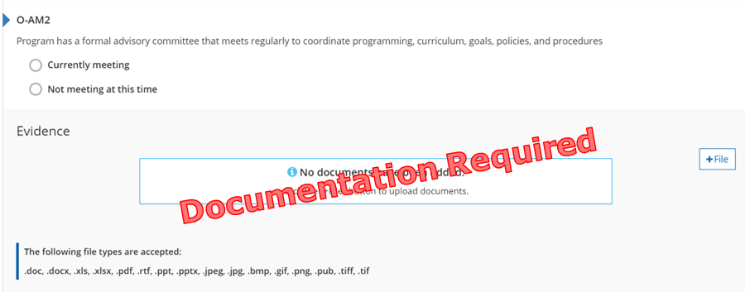
Figure 19. O-AM2 Indicator

Why this Indicator is Important
Establishing a formal advisory committee allows the program to gather input on program design and implementation to ensure the program is meeting the needs of schoolagers, families, and staff served.

How a Program May Meet the Intent of the Indicator
☐ Meeting minutes listing stakeholders.
☐ Meeting agendas listing stakeholders.
☐ Meeting schedule listing stakeholders.
☐ Sign-in sheets.
☐ Other: Enter other ways the program meets the O-AM2 Indicator
Advisory committee meetings must include at least three of the following stakeholders:
- Administrators
- Program Staff
- School Staff
- Community members
- Schoolagers
- Family members

Meeting the Indicator
The program has evidence of a formal advisory committee that meets, at minimum, twice a year.
Michigan’s Out-of-School Time Standards of Quality
VI. Administration B. Stakeholders, including: parents; guardians; family members; school personnel; businesses; service organizations; and others in the school and community, are identified and involved in the planning process and/or informed of the program.

Reflection
☐ Currently Meeting
Document Name and Location: Enter Document Name and Location for O-AM2 Indicator
Future Improvements: Enter Future Improvements for O-AM2 Indicator
☐ Not Currently Meeting
Goal for the future: Enter Future Goal for O-AM2 Indicator
What do I want to learn? Enter Desired Learning for O-AM2 Indicator
Plan for implementation: Enter Implementation Plan for O-AM2 Indicator

Points Possible for Administration and Management (6 pts.)
- Program has a formal advisory committee in place (1 pt.)

O-AM3: Program has a flexible benefit plan that may include health insurance, tuition assistance, and other benefits for full-time staff
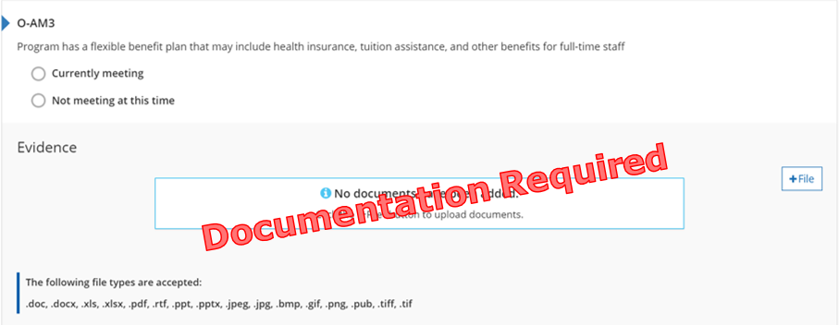
Figure 20. O-AM3 Indicator

Why this Indicator is Important
Flexible benefits encourage recruitment and retainment of qualified staff. Recruiting and retaining staff ensures high quality programming and relationships between staff and schoolagers.

How a Program May Meet the Intent of the Indicator
☐ Provides benefits which may include:
- Health insurance
- Dental insurance
- Vision insurance
- Tuition assistance
- Child care discounts
- Payouts for not participating in insurance programs
- Paying for educator professional development or time for attending professional development
☐ Written benefit plan
☐ Plan within policy and procedure manual
☐ Policy/plan in the staff/employee handbook
☐ Other: Enter other ways the program meets the O-AM3 Indicator

Meeting the Indicator
The program has evidence of the benefits provided to full-time staff.
Michigan’s Out-of-School Time Standards of Quality
III Program Staffing D. Policies and standards are developed and written related to staff qualifications for each position, including written job descriptions used in recruiting and hiring staff.

Reflection
☐ Currently Meeting
Document Name and Location: Enter Document Name and Location for O-AM3 Indicator
Future Improvements: Enter Future Improvements for O-AM3 Indicator
☐ Not Currently Meeting
Goal for the future: Enter Future Goal for O-AM3 Indicator
What do I want to learn? Enter Desired Learning for O-AM3 Indicator
Plan for implementation: Enter Implementation Plan for O-AM3 Indicator

Points Possible for Administration and Management (6 pts.)
- Program has flexible benefits in place (1 pt.)

O-AM4: Program has paid leave time for full-time employees that may include holiday, vacation, education, or sick time
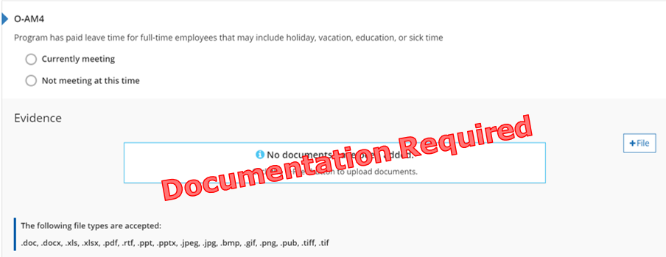
Figure 21. O-AM4 Indicator

Why this Indicator is Important
Paid leave time encourages recruitment and retainment of qualified staff. Recruiting and retaining staff ensures high quality programming and relationships between staff and schoolagers

How a Program May Meet the Intent of the Indicator
☐ Provides paid leave time which may include:
- Paid personal time
- Paid sick time
- Paid vacation time
- Paid holidays
- Paid snow days
☐ Written paid leave time plan
☐ Plan within policy and procedure manual
☐ Policy/plan in the staff/employee handbook
☐ Other: Enter other ways the program meets the C-AM4 Indicator

Meeting the Indicator
Program has evidence of the paid leave time provided to full-time staff.
Michigan’s Out-of-School Time Standards of Quality
III Program Staffing D. Policies and standards are developed and written related to staff qualifications for each position, including written job descriptions used in recruiting and hiring staff.

Reflection
☐ Currently Meeting
Document Name and Location: Enter Document Name and Location for O-AM4 Indicator
Future Improvements: Enter Future Improvements for O-AM4 Indicator
☐ Not Currently Meeting
Goal for the future: Enter Future Goal for O-AM4 Indicator
What do I want to learn? Enter Desired Learning for O-AM4 Indicator
Plan for implementation: Enter Implementation Plan for O-AM4 Indicator

Points Possible for Administration and Management (6 pts.)
- Program has paid leave time in place (1 pt.)

O-AM5: Program has a documented, graduated salary scale that takes into account education and experience
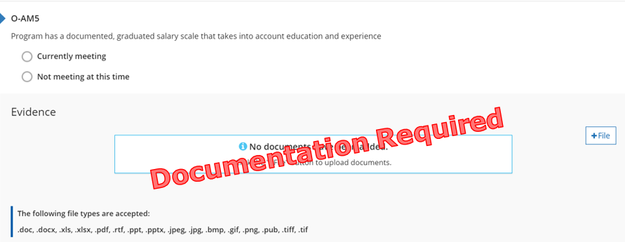
Figure 22. O-AM5 Indicator

Why this Indicator is Important
Offering a graduated salary scale encourages recruitment and retainment of qualified staff. Recruiting and retaining staff ensures high quality programming and relationships between staff and schoolagers.

How a Program May Meet the Intent of the Indicator
☐ Written policies and procedures on pay/salary.
☐ Scale within policy and procedure manual.
☐ Scale/policy in the staff/employee handbook.
☐ Other: Enter other ways the program meets the C-AM5 Indicator
The salary scale needs to be used at all times, not only when a staff member is being evaluated.
Salary scale must take into account both education and experience.

Meeting the Indicator
The program has evidence of a written salary scale taking into account education and experience.
Michigan’s Out-of-School Time Standards of Quality
III. Program Staffing I. A written, board-approved compensation plan is developed to retain qualified staff and maintain quality programs.

Reflection
☐ Currently Meeting
Document Name and Location: Enter Document Name and Location for O-AM5 Indicator
Future Improvements: Enter Future Improvements for O-AM5 Indicator
☐ Not Currently Meeting
Goal for the future: Enter Future Goal for O-AM5 Indicator
What do I want to learn? Enter Desired Learning for O-AM5 Indicator
Plan for implementation: Enter Implementation Plan for O-AM5 Indicator

Points Possible for Administration and Management (6 pts.)
- Program has a salary scale in place (1 pt.)
Total points for Administration and Management Section: Choose total points for Administration and Management Section

O-SQ1-A to D: Program Director/Site Supervisor Qualifications
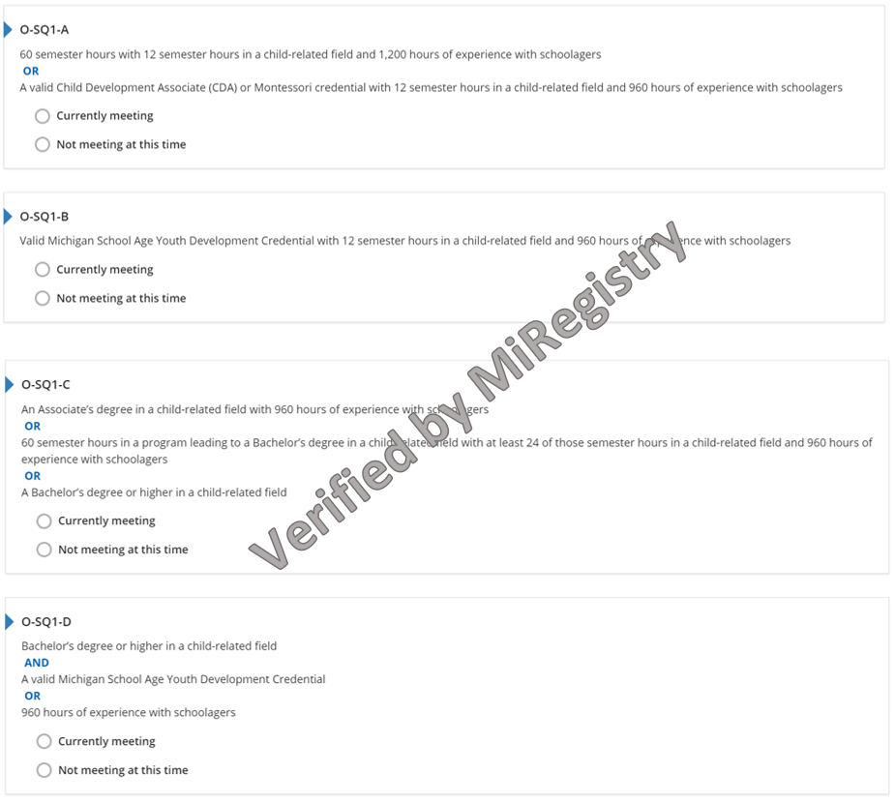
Figure 23. O-SQ1-A to D Indicators

Why this Indicator is Important
Obtaining specialized education and training allows Program Directors/Site Supervisors to provide quality care, experiences, and environments that support every aspect of schoolagers’ growth and learning.

How a Program May Meet the Intent of the Indicator
The Program Director/Site Supervisor has experience working in the field of education, is a member of MiRegistry, has their qualifications verified, and meets the intent of one of the Program Director/Site Supervisor Qualifications indicators:
- 60 semester hours with 12 semester hours in a child-related field and 1,200 hours of experience with schoolagers.
- A valid Child Development Associate (CDA), 12 semester hours in a child-related field, and 960 hours of experience with schoolagers.
- Montessori credential from the Association Montessori International (AMI), American Montessori Society (AMS) or Montessori Accreditation Council for Teacher Education (MACTE), 12 semester hours in a child-related field, and 960 hours of experience with schoolagers.
- A valid Michigan School Age Youth Development Credential, 12 semester hours in a child-related field, and 960 hours of experience with schoolagers.
- An Associates degree in a child-related field and 960 hours of experience with schoolagers.
- Working on a Bachelor’s degree in a child-related field with 60 completed semester hours, 24 semesters hours in a child-related field, and 960 hours of experience with schoolagers.
- A Bachelor’s degree (or higher) in a child-related field.
- A Bachelor’s degree (or higher) in a child-related field AND A valid Michigan School Age Youth Development Credential.
- A Bachelor’s degree (or higher) in a child-related field AND 960 hours of experience with schoolagers.
Michigan’s Out-of-School Time Standards of Quality
III. Program Staffing F. Each site has an adult site supervisor or director with decision-making responsibilities.

O-SQ1-A to D: Program Director/Site Supervisor Qualifications

Staffing
Name of Program Director/Site Supervisor: Enter Name of Program Director/Site Supervisor
☐ Program Director/Site Supervisor is connected to the Organization Profile.
☐ Program Director/Site Supervisor is connected to the Classrooms Tab of STARS.
☐ Qualifications sent to MiRegistry for verification.

Reflection
☐ Currently Meeting
Program Director/Site Supervisor Qualifications Indicator currently meeting: Select Program Director/Site Supervisor Qualifications Indicator currently meeting
Future Improvements: Enter Future Improvements for Program Director/Site Supervisor Qualifications
☐ Not Currently Meeting
Goal for the future: Enter Future Goal for Program Director/Site Supervisor Qualifications
What do I want to learn? Enter Desired Learning for Program Director/Site Supervisor Qualifications
Plan for implementation: Enter Implementation Plan for Program Director/Site Supervisor Qualifications

Points Possible for Program Director/Site Supervisor Qualifications (1 to 4 pts.)
Administrator meets O-SQ1-A (1 pt.)
- 60 semester hours with 12 semester hours in a child-related field and 1,200 hours of experience with schoolagers OR A valid Child Development Associate (CDA) or Montessori credential with 12 semester hours in a child-related field and 960 hours of experience with schoolagers
Administrator meets O-SQ1-B (2 pts.)
- Valid Michigan School Age Youth Development Credential with 12 semester hours in a child-related field and 960 hours of experience with schoolagers.
Administrator meets O-SQ1-C (3 pts.)
- An Associates degree in a child-related field with 960 hours of experience with schoolagers OR 60 semester hours in a program leading to a Bachelor’s degree in a child-related field with at least 24 of those semester hours in a child-related field and 960 hours of experience with schoolagers OR A Bachelor’s degree or higher in a child-related field.
Administrator meets O-SQ1-D (4 pts.)
- Bachelor’s degree or higher in a child-related field AND A valid Michigan School Age Youth Development Credential OR 960 hours of experience with schoolagers.
Total points for Program Director/Site Supervisor Qualifications Section: Choose total points for Program Director/Site Supervisor Qualifications Section

O-SQ2-A to D: Program Staff Qualifications
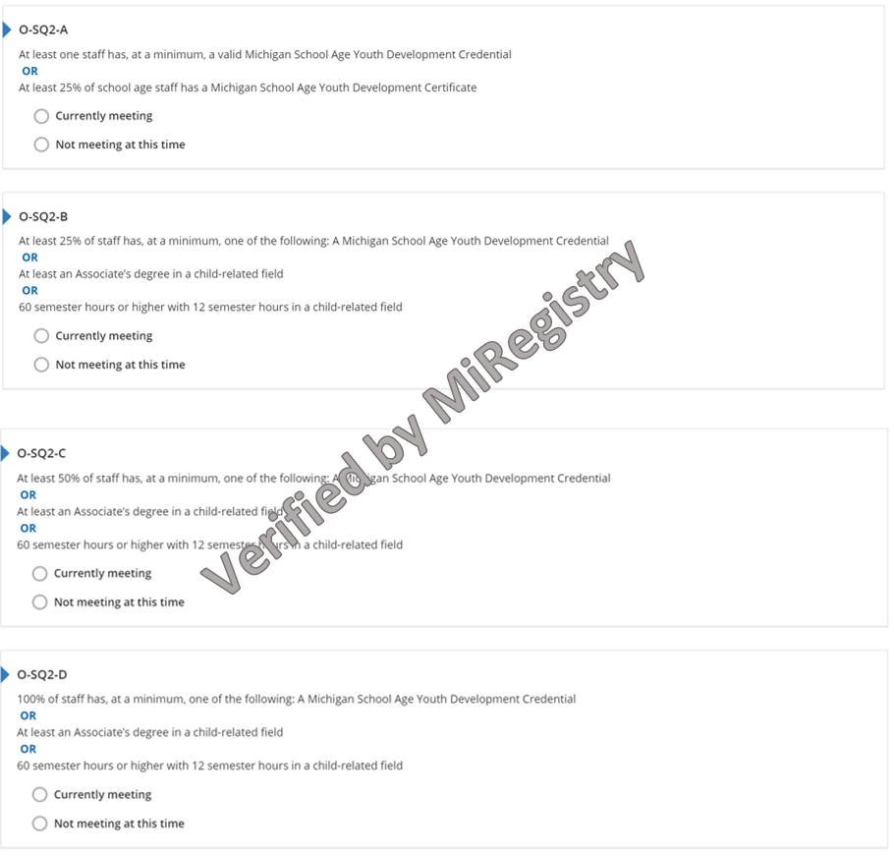
Figure 24. O-SQ2-A to D Indicators

Why this Indicator is Important
Obtaining specialized education and training allows staff to provide quality care, experiences, and environments that support every aspect of schoolagers’ growth and learning.

How a Program May Meet the Intent of the Indicator
The Program Staff has experience working in the field of education, is a member of MiRegistry, has their qualifications verified, and meets the intent of one of the Program Staff Qualifications indicators:
- A valid Michigan School Age Youth Development Credential.
- A Michigan School Age Youth Development Certificate.
- An Associates degree in a child-related field.
- 60 semester hours (or higher) with 12 semester hours in a child-related field.
Michigan’s Out-of-School Time Standards of Quality
III. Program Staffing G. Program staff working directly with students are well trained with appropriate experience to work in the OST field with children and youth.

O-SQ2-A to D: Program Staff Qualifications

Staffing
Name of Program Staff: Enter Name of Program Staff
☐ Program Staff is connected to the Organization Profile.
☐ Program Staff is connected to the Classrooms Tab of STARS.
☐ Qualifications sent to MiRegistry for verification.

Reflection
☐ Currently Meeting
Program Staff Qualifications Indicator currently meeting: Select Program Staff Qualifications Indicator currently meeting
Future Improvements: Enter Future Improvements for Program Staff Qualifications
☐ Not Currently Meeting
Goal for the future: Enter Future Goal for Program Staff Qualifications
What do I want to learn? Enter Desired Learning for Program Staff Qualifications
Plan for implementation: Enter Implementation Plan for Program Staff Qualifications

Points Possible for Program Staff Qualifications (2 to 5 pts.)
Administrator meets O-SQ2-A (2 pts.)
- At least one staff has, at a minimum, a valid Michigan School Age Youth Development Credential OR At least 25% of school age staff has a Michigan School Age Youth Development Certificate.
Administrator meets O-SQ2-B (3 pts.)
- At least 25% of staff has, at a minimum, one of the following: A Michigan School Age Youth Development Credential OR At least an Associates degree in a child-related field OR 60 semester hours or higher with 12 semester hours in a child-related field.
Administrator meets O-SQ2-C (4 pts.)
- At least 50% of staff has, at a minimum, one of the following: A Michigan School Age Youth Development Credential OR At least an Associates degree in a child-related field OR 60 semester hours or higher with 12 semester hours in a child-related field.
Administrator meets O-SQ2-D (5 pts.)
- 100% of staff has, at a minimum, one of the following: A Michigan School Age Youth Development Credential OR At least an Associates degree in a child-related field OR 60 semester hours or higher with 12 semester hours in a child-related field.
Total points for Program Staff Qualifications Section: Choose total points for Program Staff Qualifications Section

O-PD1: Director and all program staff complete at least 24 clock hours of professional development annually
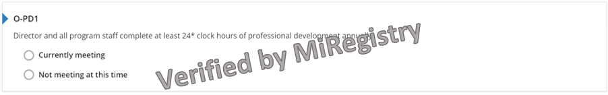
Figure 25. O-PD1 Indicator

Why this Indicator is Important
Continued professional development and training supports staff members’ knowledge on current best practices, providing quality care, experiences, and environments that support every aspect of schoolagers’ growth and learning.

How a Program Meets the Intent of the Indicator
The Director and all program staff have:
- Completed 24 hours of professional development within the last 12 months from the month the Self-Assessment Survey was submitted.
- Professional development training verified by MiRegistry.
Recently hired staff (hired for less than 90 days) do not require a certain number of professional development training hours.
CPR and First Aid hours do not count toward the total professional development hours.
Michigan’s Out-of-School Time Standards of Quality
III. Program Staffing H. A written plan for on- going staff development is implemented and budgeted.

Reflection
☐ Currently Meeting
Document Name and Location: Enter Document Name and Location for O-PD1 Indicator
Future Improvements: Enter Future Improvements for O-PD1 Indicator
☐ Not Currently Meeting
Goal for the future: Enter Future Goal for O-PD1 Indicator
What do I want to learn? Enter Desired Learning for O-PD1 Indicator
Plan for implementation: Enter Implementation Plan for O-PD1 Indicator

Points Possible for Professional Development Section (7 pts.)
- Program has evidence of annual professional development in place (2 pts.)

O-PD2: Annual professional development attended includes at least 2 hours focused on cultural competence or inclusive practices related to serving schoolagers with special needs or disabilities
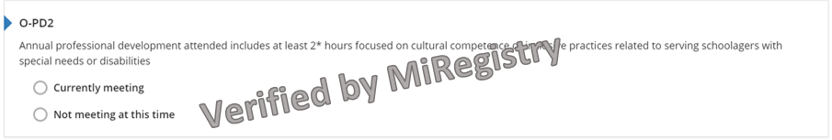
Figure 26. O-PD2 Indicator

Why this Indicator is Important
Ongoing professional development trainings support staff members’ knowledge on current best practices related to cultural competence or inclusive practices (e.g., culture, diversity, special needs, inclusion, etc.) as it relates to caring for and serving schoolagers.

How a Program Meets the Intent of the Indicator
The Director and all staff have:
- Completed 2 hours of professional development focused on cultural competence/inclusive practices (e.g., serving children with special needs or disabilities, teaching diverse children, supporting diverse children and their families, etc.) within the last 12 months from the month the Self-Assessment Survey was submitted.
- Professional development training verified by MiRegistry.
Recently hired staff (hired for less than 90 days) do not require a certain number of professional development training hours.
Michigan’s Out-of-School Time Standards of Quality
III. Program Staffing H. A written plan for on- going staff development is implemented and budgeted.

Reflection
☐ Currently Meeting
Document Name and Location: Enter Document Name and Location for O-PD2 Indicator
Future Improvements: Enter Future Improvements for O-PD2 Indicator
☐ Not Currently Meeting
Goal for the future: Enter Future Goal for O-PD2 Indicator
What do I want to learn? Enter Desired Learning for O-PD2 Indicator
Plan for implementation: Enter Implementation Plan for O-PD2 Indicator

Points Possible for Professional Development Section (7 pts.)
- Program has evidence of professional development focused on cultural competence or inclusive practices in place (2 pt.)

O-PD3: Annual professional development attended by staff has at least 2 hours focused specifically on family engagement
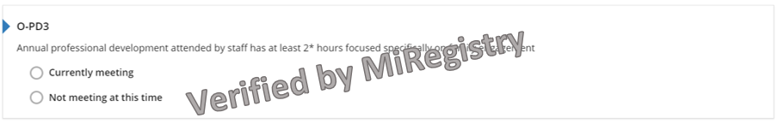
Figure 27. O-PD3 Indicator

Why this Indicator is Important
Ongoing professional development trainings support staff members’ knowledge in family engagement as it relates to caring for and serving schoolagers.

How a Program Meets the Intent of the Indicator
The Director and all staff have:
- Completed 2 hours of professional development focused specifically on family engagement within the last 12 months from the month the Self-Assessment Survey was submitted.
- Professional development training verified by MiRegistry.
Recently hired staff (hired for less than 90 days) do not require a certain number of professional development training hours.
Michigan’s Out-of-School Time Standards of Quality
III. Program Staffing H. A written plan for on- going staff development is implemented and budgeted.

Reflection
☐ Currently Meeting
Document Name and Location: Enter Document Name and Location for O-PD3 Indicator
Future Improvements: Enter Future Improvements for O-PD3 Indicator
☐ Not Currently Meeting
Goal for the future: Enter Future Goal for O-PD3 Indicator
What do I want to learn? Enter Desired Learning for O-PD3 Indicator
Plan for implementation: Enter Implementation Plan for O-PD3 Indicator

Points Possible for Professional Development Section (7 pts.)
- Program has evidence of professional development focused on cultural competence or inclusive practices in place (2 pt.)

O-OS1: Program develops Quality Improvement Plan designed to improve quality in staff qualifications and progress is monitored by a person with a Master’s degree in a child-related field or a Quality Improvement Consultant
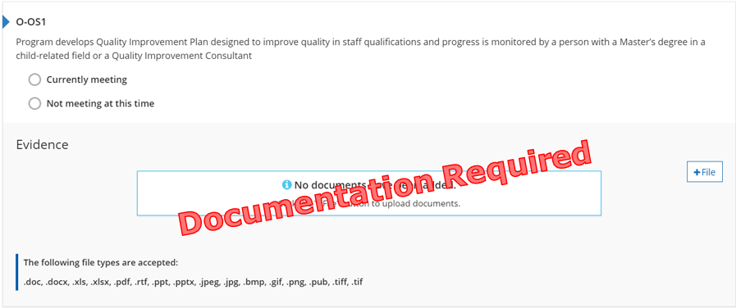
Figure 28. O-OS1 Indicator

Why this Indicator is Important
Monitoring a program’s written plan to encourage program quality and work on staff qualifications shows a dedication to improvement and high-quality programming.

How a Program May Meet the Intent of the Indicator
- A Quality Improvement Plan is a document that states the program’s goals for improving staff qualifications, the plan to reach those goals, and the steps that will be taken to achieve/complete the goals.
- Quality Improvement Plans from outside STARS will meet the intent of this indicator if the plan clearly explains how the program is working to improve staff qualifications.
- Professionals other than Quality Improvement Consultants may monitor the progress, if they have a Master’s degree (or higher) in Early Childhood Education, Child Development, or a child-related field.

Meeting the Indicator
The program has evidence of a Quality Improvement Plan designed to improve staff qualifications that is monitored by someone with a Master’s degree or a Quality Improvement Consultant.
Michigan’s Out-of-School Time Standards of Quality
VI. Administration F. A system of regular and comprehensive program evaluation is established and used for on-going program improvement.

Reflection
☐ Currently Meeting
Document Name and Location: Enter Document Name and Location for O-OS1 Indicator
Future Improvements: Enter Future Improvements for O-OS1 Indicator
☐ Not Currently Meeting
Goal for the future: Enter Future Goal for O-OS1 Indicator
What do I want to learn? Enter Desired Learning for O-OS1 Indicator
Plan for implementation: Enter Implementation Plan for O-OS1 Indicator

Points Possible for Professional Development Section (7 pts.)
- Program has evidence of a Quality Improvement Plan in place (1 pt.)
Total points for Professional Development Section: Choose total points for Professional Development Section

Calculating Potential Self-Assessment Survey Score

Total Section Score
Enter the total points for each section of the Self-Assessment Survey. Reference page for each section is in parenthesis. Add each total category score in the SAS Points column below. Add all category scores to determine total points. Remember to reference the minimum points and minimum categories to achieve each rating level.

Family and Community Partnership
Family and Community Partnership (Page 11): ___
Total Category Score: ___
Environment
Ratios (Page 12): ___
Health Environment (Page 15): ___
Total Category Score: ___
Curriculum and Instruction
Curriculum and Instruction (Page 20): ___
Total Category Score: ___
Administration and Management
Administration and Management (Page 25): ___
Total Category Score: ___
Staff Qualifications and Professional Development
Administrator/Director/Site Supervisor Qualifications (Page 27): ___
Program Staff Qualifications (Page 29): ___
Professional Development (Page 33): ___
Total Category Score: ___

Category Possible Points SAS
Per Category Points 2 Star 3 Star 4 Star 5 Star
Family and Community Partnerships 8 ___ 4 4 6 6
Environment 8 ___ 2 4 6 6
Curriculum and Instruction 12 ___ 4 6 8 8
Administration and Management 6 ___ 2 4 4 4
Staff Qualifications and PD 16 ___ 3 6 8 8
Additional points in any other category ___ 1 2 6 10
Total 50 ___

Minimum points/minimum categories 16/2 26/3 38/4 42/5

